*A project report on*

**Development of web application using HTML & CSS for STUDENT INFORMATION SYSTEM.**

*Submitted in partial fulfillment for the award of the degree of*

**MTSE**

*by*

**R V S TEJA KRISHNA (17MIS7085)**



**AMARAVATI**

**School of M.Tech Intergrated Software Engineering**

May, 2019



**AMARAVATI**

**MTSE**

May, 2019

**CERTIFICATE**

This is to certify that the thesis entitled “Development of Mobile web application using HTML & CSS for **Student Information System.** “Submitted by R V S TEJA KRISHNA (17MIS7085) School of M.Tech Integrated Software Engineering VIT-AP, for the award of the Summer Internship for the bonafide work carried out by him under my supervision.

The contents of this report have not been submitted and will not be submitted  
either in part or in full, for the award of any other degree or diploma in this institute or  
any other institute or university. The Project report fulfils the requirements and regulations of  
VIT-AP and in my opinion meets the necessary standards for submission.

**Signature of the Guide**  **Signature of the HOD**

**ACKNOWLEDGEMENT**

It is my pleasure to express with deep sense of gratitude to Prof. Hussain Syed, for his constant guidance, continual encouragement, understanding more than all. He taught me patience in my endeavour. My association with him is not confined to academics only, but it is a great opportunity on my part of work with an intellectual and expert in the field of software.

I would like to express my gratitude to Mr. G Vishwanathan, Mr.SankarViswanathan and School of M.Tech Integrated Software Engineering for providing with an environment to work in and for his inspiration during the tenure of the course.

In jubilant mood I express ingeniously my whole-hearted thanks to the Program Chair and all teaching staff and members working as limbs of our university for their non self-centred enthusiasm coupled with timely encouragements showered on me with zeal, which prompted the acquirement of the requisite knowledge to finalize my course study successfully. I would like to thank my parents for their support.

It is indeed a pleasure to thank my friends who persuaded and encouraged me to take up and complete this task. At last but not least, I express my gratitude and appreciation to all those who have helped me directly or indirectly toward the successful completion of this project.

Place: Amaravathi R V S TEJA KRISHNA.

Date: Name of the student

**DECLARATION**

We hereby declare that project entitled **STUDENT INFROMATION SYSTEM** submitted in partial fulfillment of the requirements for the award of degree of Masters of Technology in Software Engineering. This dissertation is our original work and the project has not formed the basis for the award of any degree, associate ship, fellowship or any other similar titles and no part of it has been published or sent for the publication at the time of submission.

**R V S TEJA KRISHNA(17MIS7085)**

**Table of Contents**

1. INTRODUCTION
   1. ABSTRACT
2. PROBLEM DEFINITION
3. SYSTEM ANALYSIS
   1. EXISTINGSYSTEM
   2. PROPOSED SYSTEM
4. FEASIBILITY STUDY
   1. TYPES OF FEASIBILITY
5. PROJECT OVERVIEW
   1. PROJECT MODULES
6. DEFINITION, ACRONYMS AND ABBREVATIONS
7. SYSTEM REQUIREMENTS
8. SYSTEM DESIGN
9. SCREENS
10. DATABASE DESIGN
11. TEST REPORT, TEST PLAN
12. CONCLUSION
13. **INTRODUCTION**

**1.1 ABSTRACT**

Student Information System deals with all kind of student details, academic related reports, college details, course details, curriculum, and batch details. It tracks all the details of a student from the day one to the end of his course which can be used for all reporting purpose, tracking of attendance, completed semesters years, coming semester year curriculum details, exam details, final exam result and all these will be available for future references too.

Project Analysis:

This project contains 4 modules, they are

Module I: College and Department Details

* This module deals with the college details and different departments in the college.
* Department details contains course, curriculam and batch details.

Module II: Student Details

* This module deals with the student academic details and personnel details.

Module III: Staff Details

* In the Staff Module that maintains about the staff Information about the classes timetable, attendance etc.

Module IV: Exam Details

* This module deals with the student exam details.

1. **PROBLEM DEFINITION**

The project will be used by the universities to share the information among the students and staff of the universities. Previously the information that is being shared was only on papers. Though the members have maintained a very perfect record of the details of students and staff, the accessibility was no ease. When students ask queries about their details or results and their attendance they may be delayed to get the reply from the staff and they can ask to staff of a particular university to which they belong. This may also delay their planned schedule.

Sometimes the absence of staff may also delay in providing the information or the material that is required by the student. The staff cannot assign their work to other staff member when they are going to absent. The searching, downloading and uploading of materials is also difficult due to storage of access amount of information in the records.

Hence to overcome the above problems a system is being developed. This system is based on Role Based Access Control. The admin has full access to the database and manages the information. The information of each and every person present in that institution is added by the admin. Here every user is provided with a unique login id and password. The staff can add the details of the attendance and results of their respective class’s details. And they do not have the access to delete the data directly through their profile. The students also will be given with a unique id and password through which they can login into the site to view their profile. In their profile they can view the details of their attendance and results till date. Thus accessing, viewing and uploading of materials is easy.

**3. SYSTEM ANALYSIS**

**3.1 EXISTING SYSTEM:**

In existing system we do not have a common platform where we canhave details of each and every person in that institution and the records of all of them are on papers only, and accessing of the information by either student or staff is found difficult when more than one person tries to access at a time. This is even hard for staff and management to maintain the record of members of the institution on paper.

**Disadvantages:**

Sharing of large amount of information is difficult.

Though the staff have every detail of the students accessing the information at the same time is found difficult.

Misplacing the records of the students or staff will make the data collection difficult.

Assigning the work to another person may give errors in the data collected.

**3.2 PROPOSED SYSTEM:**

The effective collaboration with information sharing in universities is based on role-based access control management. There are three users- admin, student and staff. Each user has respective unique id and password. Admin is responsible for adding or deleting universities, viewing the universities, their respective staff and students.

**Advantages:**

Large amount of information can be shared easily.

As only authenticated persons can access the system, more security is maintained.

There is no delay in providing updates and replying to the queries of the students.

Searching of information, uploading and downloading of materials is easy.

1. **FEASIBILITY STUDY**

A feasibility study is an evaluation of the proposal is to determine the difficulty in carry out a task. Generally a feasibility study precedes technical development and project implementation in other words, a feasibility study is a evaluation (or) analysis of the potential impact of the proposed project.

**4.1 TYPES OF FEABILITY:**

1. **TECHNOLOGY FEASIBILITY:**

The assessment is based the outline design of system required in terms of input processes, output, fields, programs and procedures. This can be quantified in terms of volumes of data trends, frequency of updating etc in order to estimate whether the new system will perform adequately or not. Technology feasibility is carried to determine whether the company has capability in terms of software, hardware, personal and expertise the completion of project.

1. **ECONOMIC FEASIBILITY:**

Economic feasibility analysis is the most frequently used method for evaluating the effectiveness of new system, commonly cost of benefit analysis. The procedure is to determine the benefits outweigh cost then the decision is made to design and implemented the system entrepreneur must accurately weigh the cost is a benefit before taking an action.

1. **LEGAL FEASIBILITY:**

Determines whether the proposed system conflicts with legal requirements eg-a data processing system comply with a local protection acts.

1. **OPERATING FEASIBILITY:**

It is a measure how we are proposed system solves the problems and takes advantages of the opportunity identify during scope definition and how it satisfies the requirements identified the requirements analysis phase of system development.

1. **SCHEDULE FEASIBILITY:**

A project will fail if it takes too long to be completion before it is used. Typically this means estimating how long the system will take to develop and if it can be completed in a given time period using so many methods like payback period. Schedule feasibility is a measure how the responsible the project timetable is.

1. **PROJECT OVERVIEW**

**5.1 PROJECT MODULES:**

Student Information System deals with all kind of student details, academic related reports, college details, course details, curriculum, and batch details. It tracks all the details of a student from the day one to the end of his course which can be used for all reporting purpose, tracking of attendance, completed semesters years, coming semester year curriculum details, exam details, final exam result and all these will be available for future references too.

This application consists of following modules:

1. College and Department details

2. Student Details

3. Staff Details

4. Exam Details

**Module 1: College and Department Details:**

This module can be viewed by any person in the university. This particular modules gives us the details of the college in brief and details of the each and every department that the institution consists. This is a kind of static page and has nothing to do as a dynamic page.

**Module 2: Student Details:**

Students can login with the unique login id and password provided to them. They can update their profile provided only few selected fields are editable such as address phone number and email. Students can also view their respective details of their attendance and their result of that current semester. Students will not be having any access over their information.

**Module 3: Staff Details:**

Staffcan also login with the unique login id and password provided to them. They can update their profile provided only few selected fields are editable such as address phone number and email. Staff can also add the details of their attendance and the result of their class in that semester. Staff will not be having any access over their information but they can upload the information of attendance and results of their respective class.

**Module 4: Exam Details:**

The admin who takes care of the website only has the access to upload the details of either student of staff and also to delete them. When he deletes a record from the students list, simultaneously the data of that student in the attendance table and results table is deleted. So exam details is a module where students and staff can view the details of the latest exam and previous exam.

1. **DEFINITION, ACRONYMS AND ABBREVATIONS**

**ABBREVATIONS:**

JSP : Java Server Pages

SQL : Structured Query Language

RBAC : Role Based Access Control

**DEFINITIONS:**

JSP:

JSP is a Web application framework developed and marketed to allow programmers to build dynamic Websites, Web applications and Web services.

SQL SERVER:

It is a software product whose primary function is to store and retrieve data as requested by other software applications, be it those on same computer or those running on another computer across network (including the Internet).

ROLE BASED ACCESS CONTROL:

Role Based Access Control is a database through which the data is accessed according the roles of the users who are accessing the database to retrieve the data.

**7. SYSTEM REQUIREMENTS**

**SOFTWARE REQUIREMENTS:**

Operating System : Windows 7

Technology : Java/J2EE (Servlets, JSP, JDBC)

Web Technologies : Html, JavaScript, CSS

Web Server : Tomcat 7.0

Database : My SQL

Software’s : JDK 1.6

**HARDWARE REQUIREMENTS:**

Hardware : Pentium based systems with a minimum of P4

RAM : 1GB (minimum)

**8.SYSTEM DESIGN**

1. **CLASS DIAGRAM**

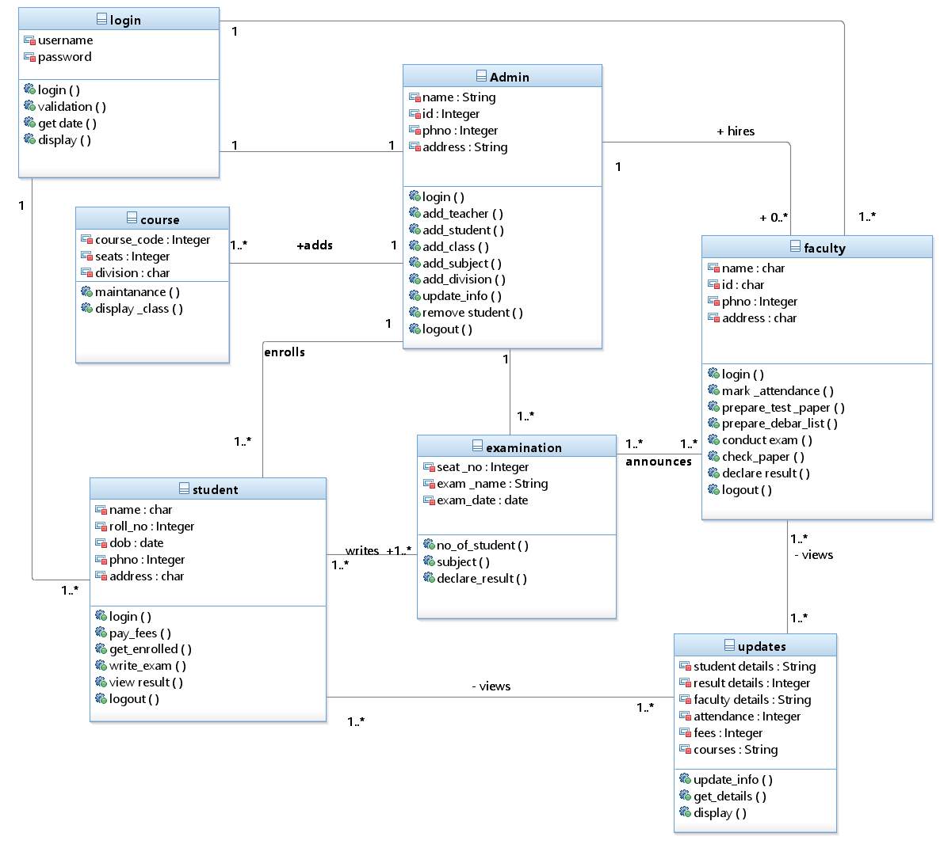

1. **USE CASE DIAGRAM**

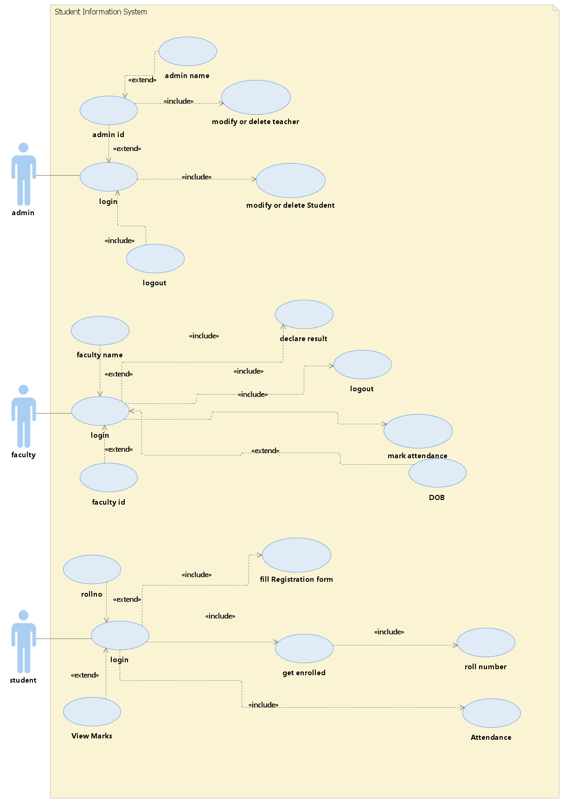

1. **SEQUENCE DIAGRAM**

For validation:

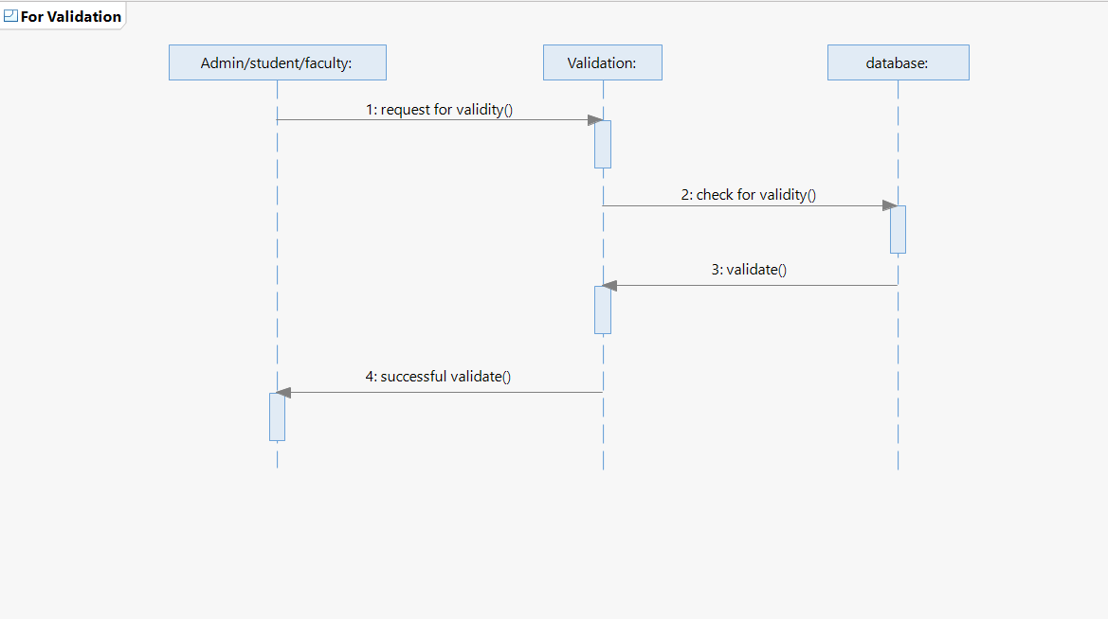

For admin:

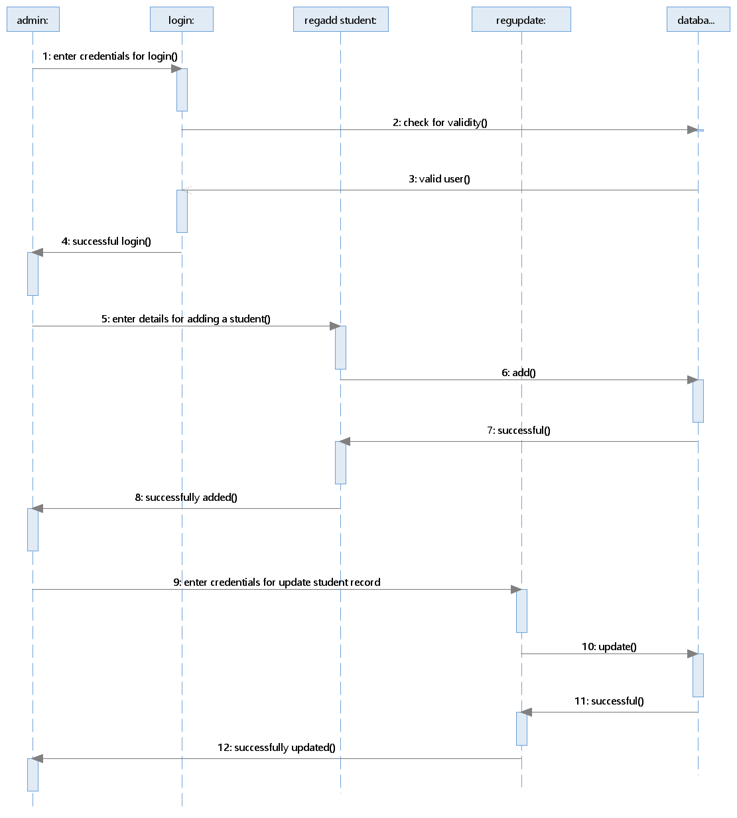

For student/faculty:

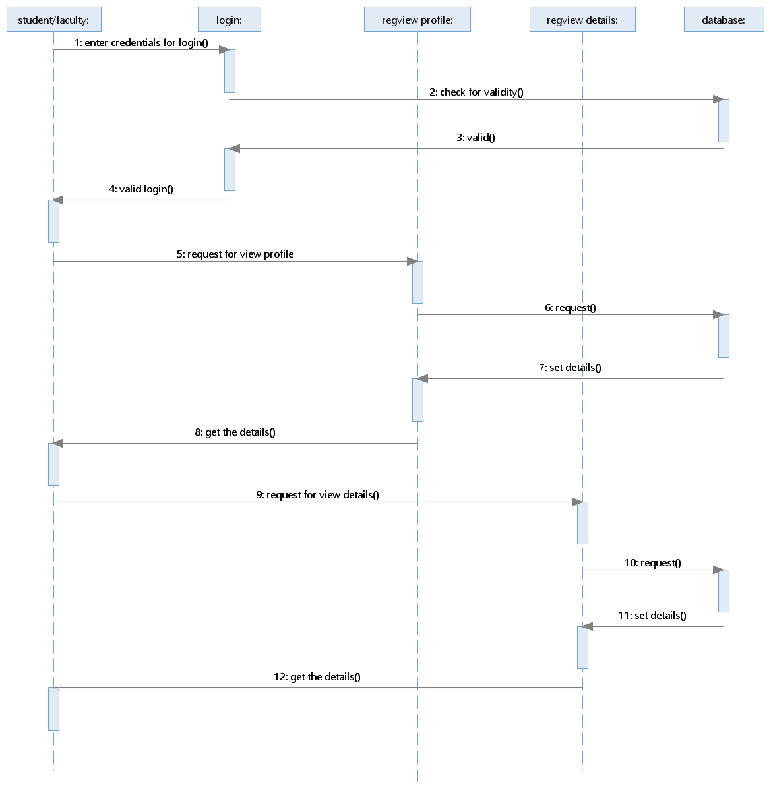­

1. **A) ACTIVITY DIAGRAM FOR ADMIN**
2. 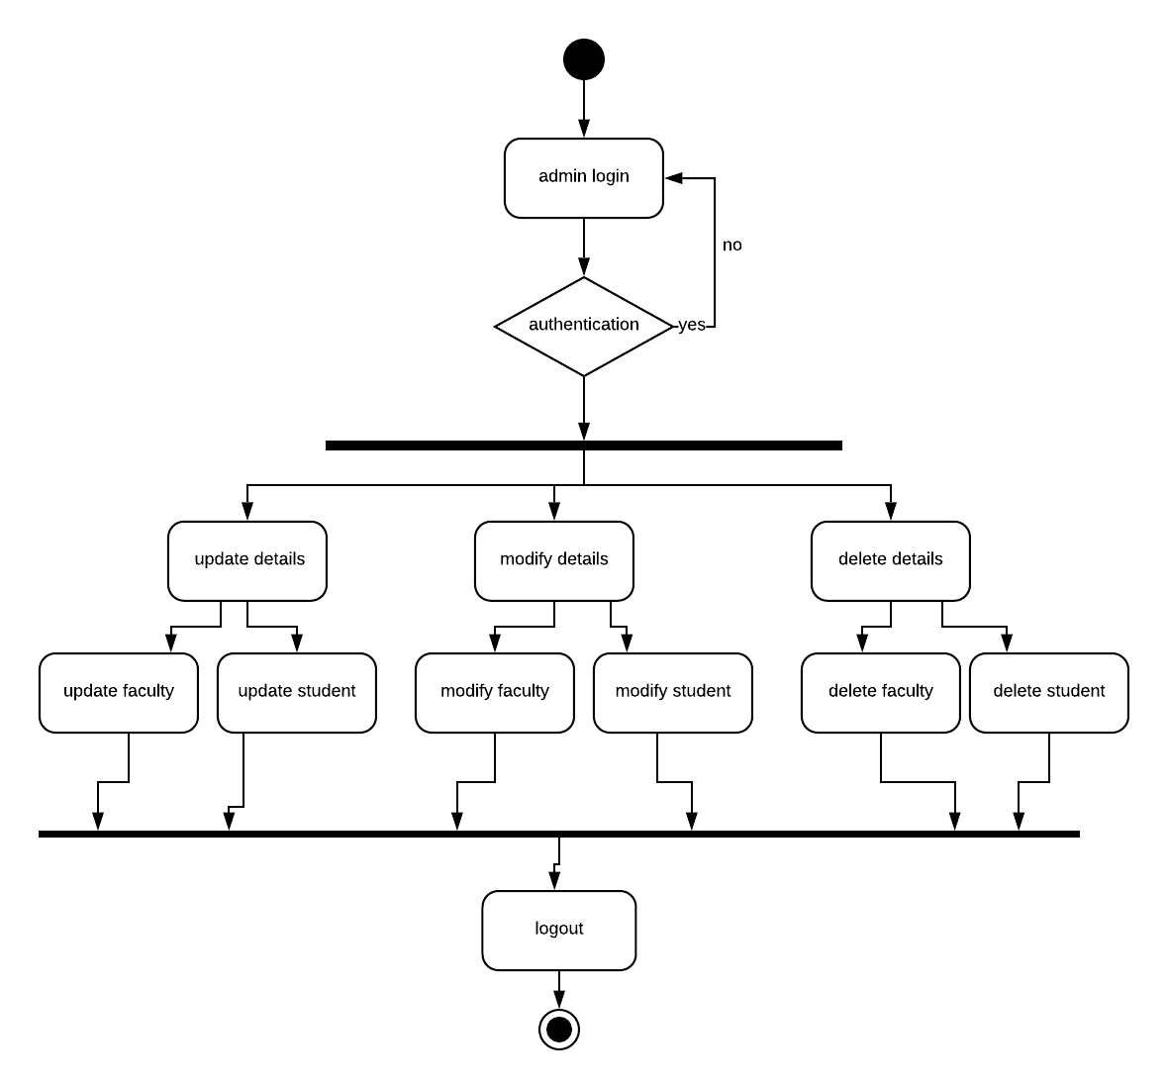

**B) ACTIVITY DUAGRAM FOR STUDENT/FACULTY**

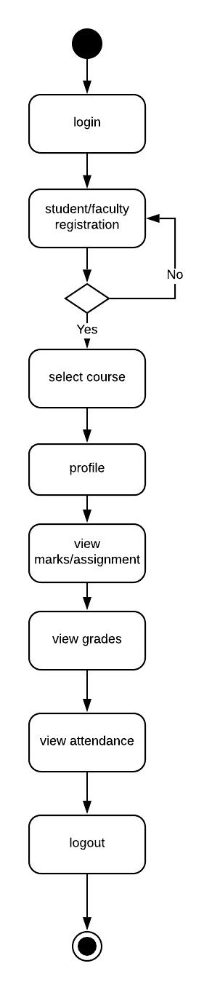

1. **SCREENS**

**HOME PAGE**

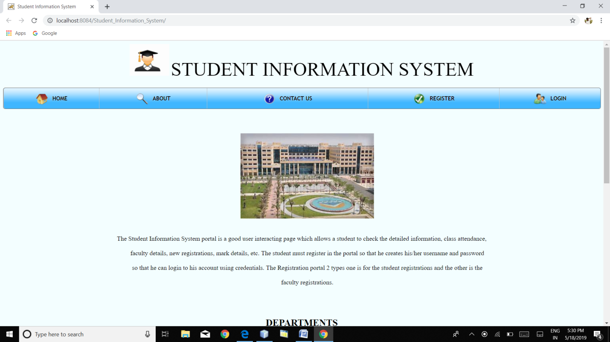

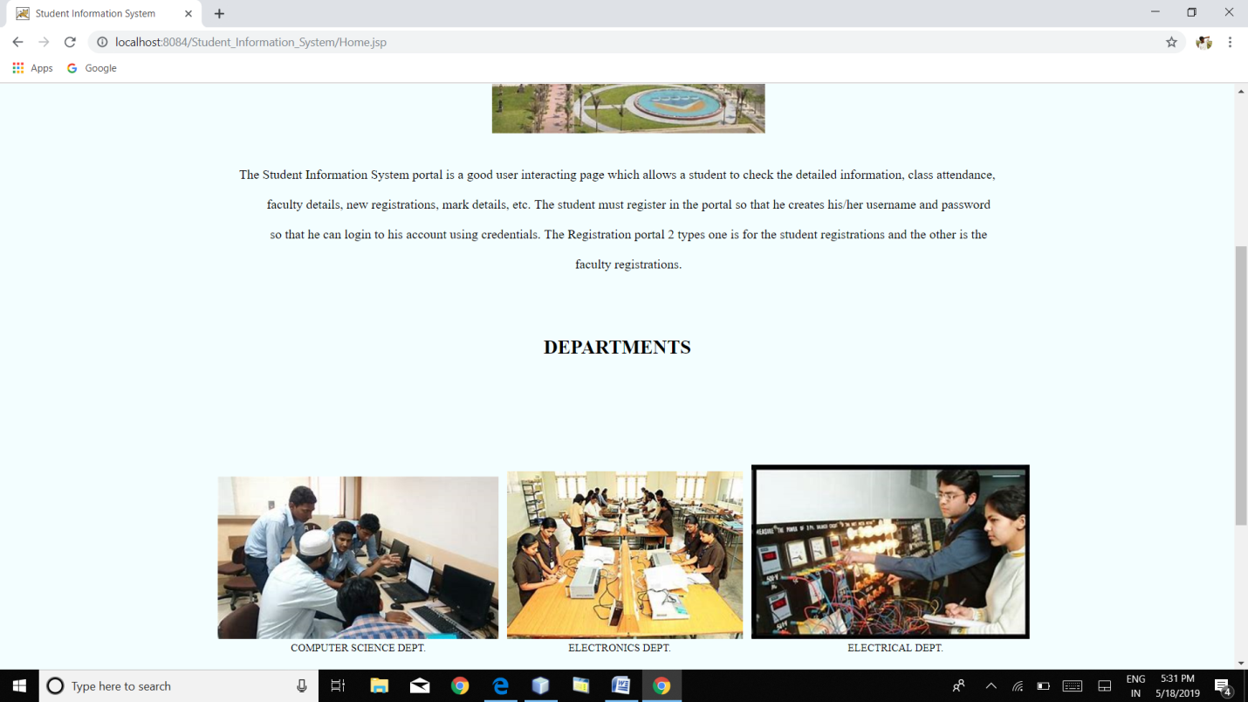

**ABOUT PAGE**

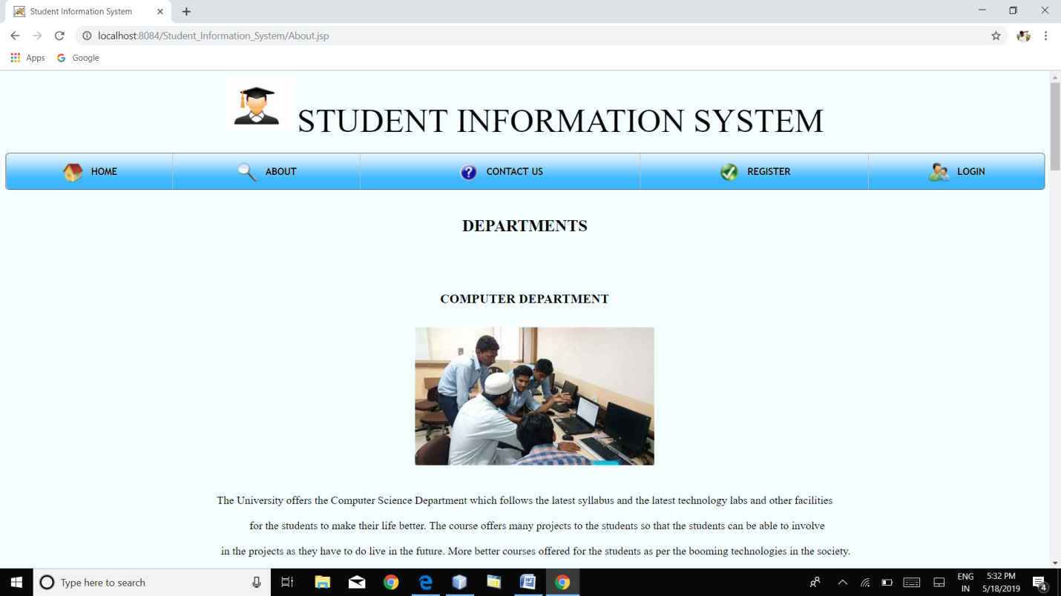

**CONTACT US**

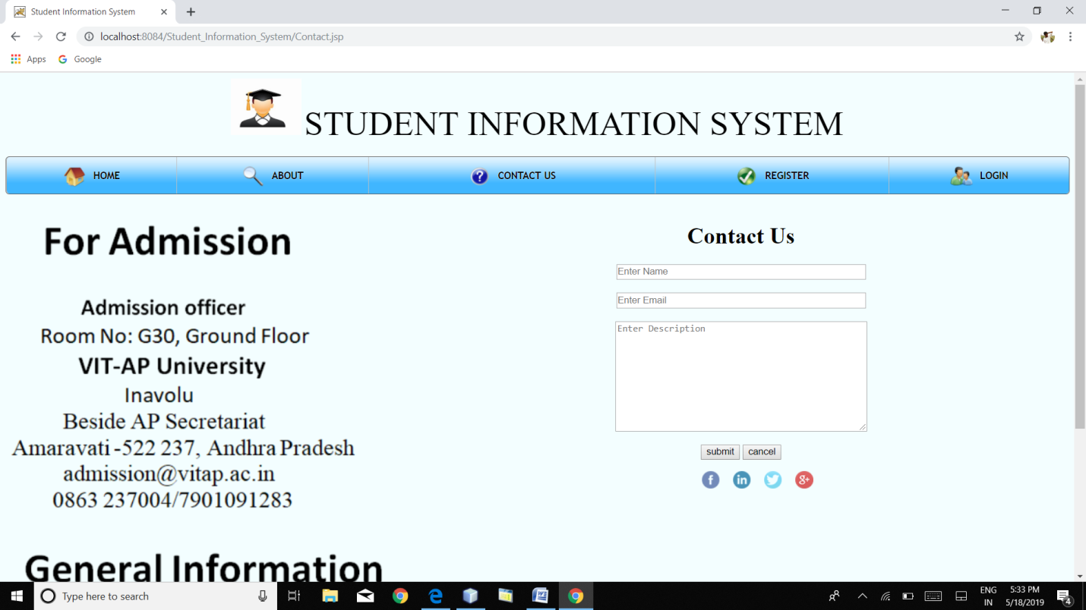

**STUDENT REGISTRATION FORM**

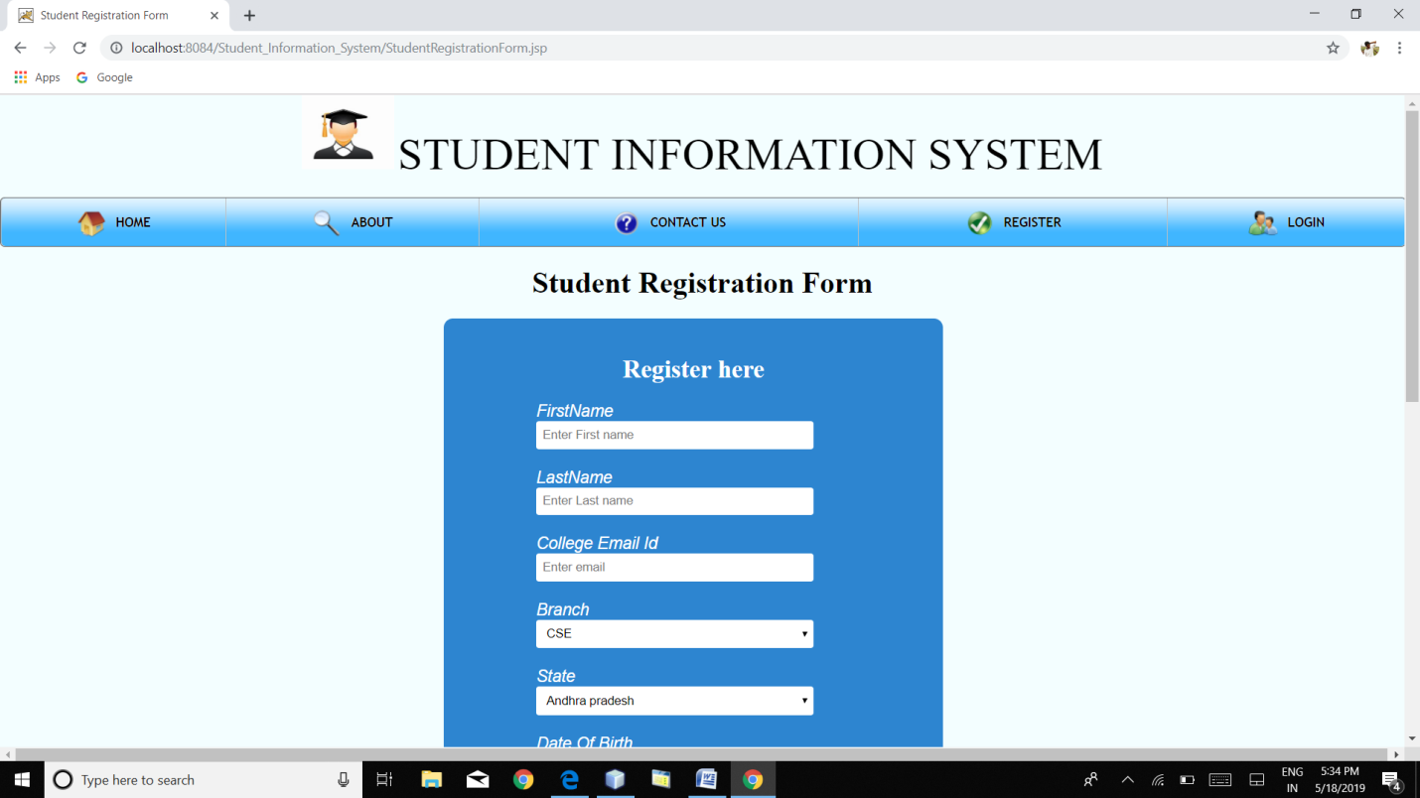

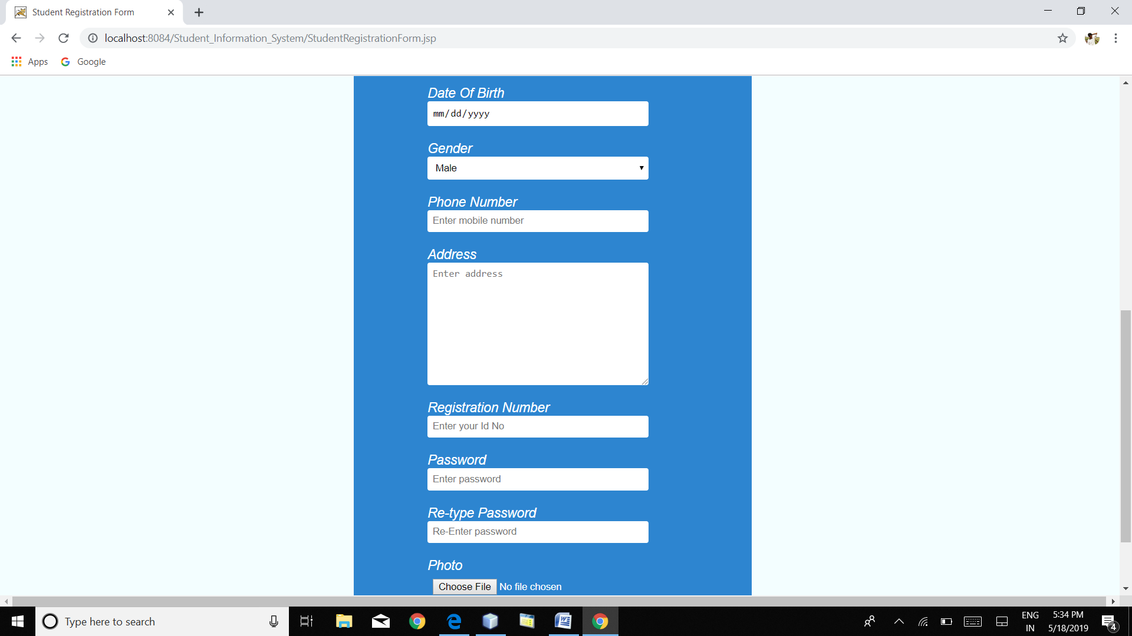

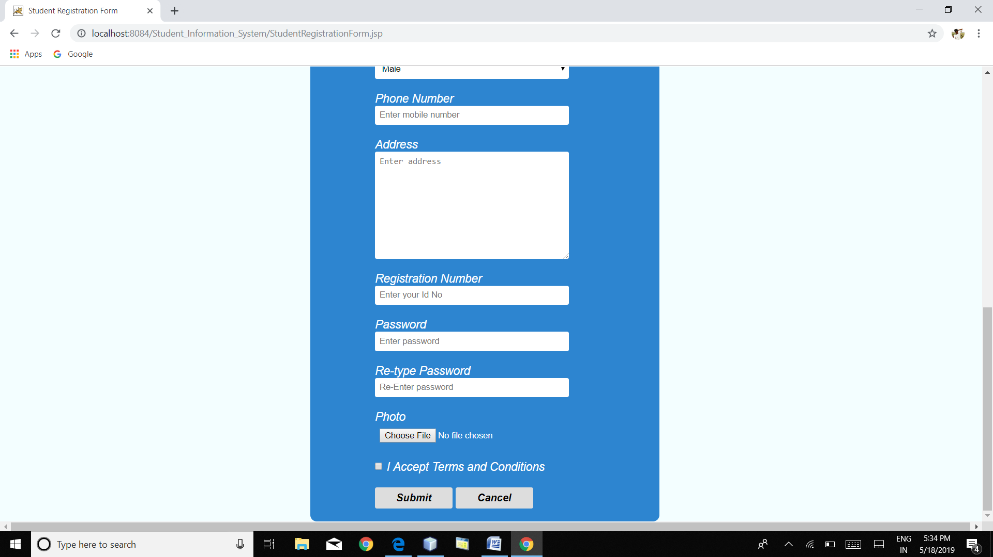

**FACULTY REGISTRATION FORM**

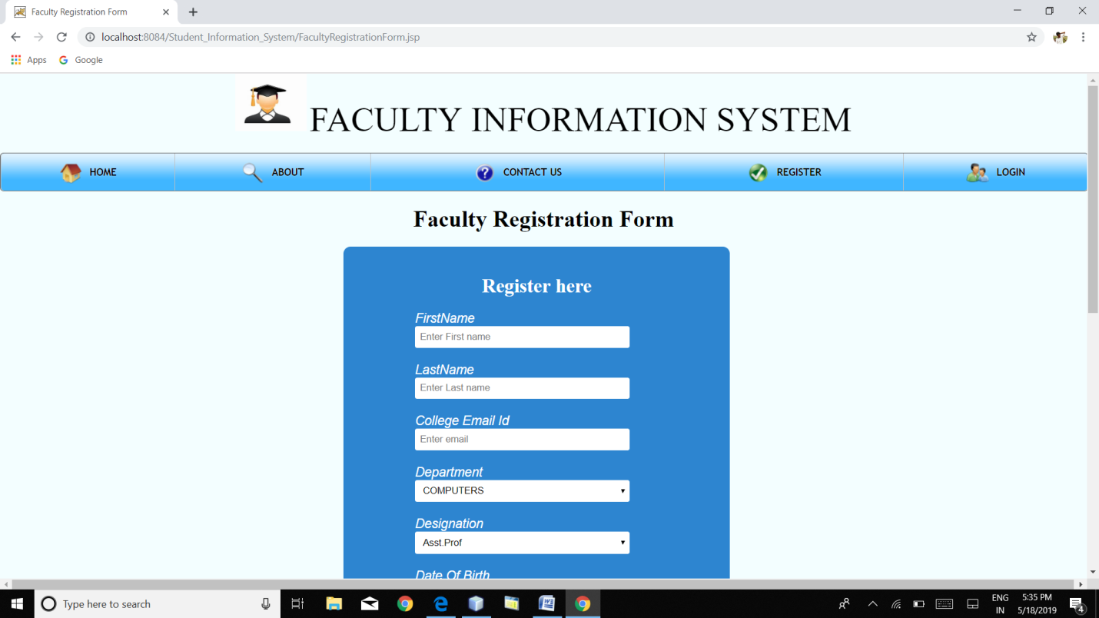

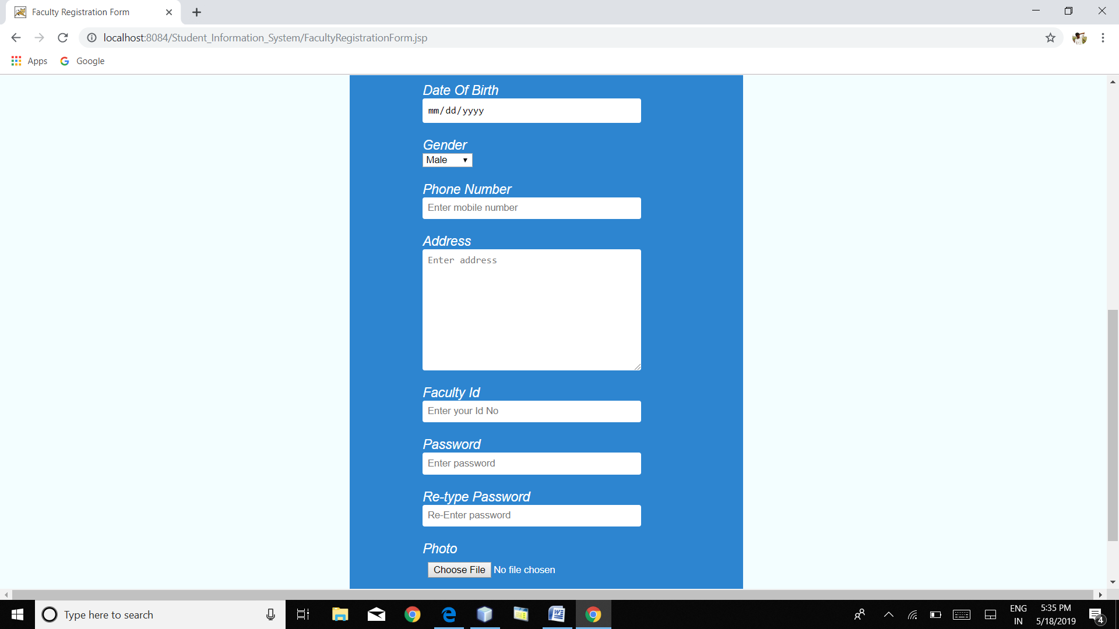

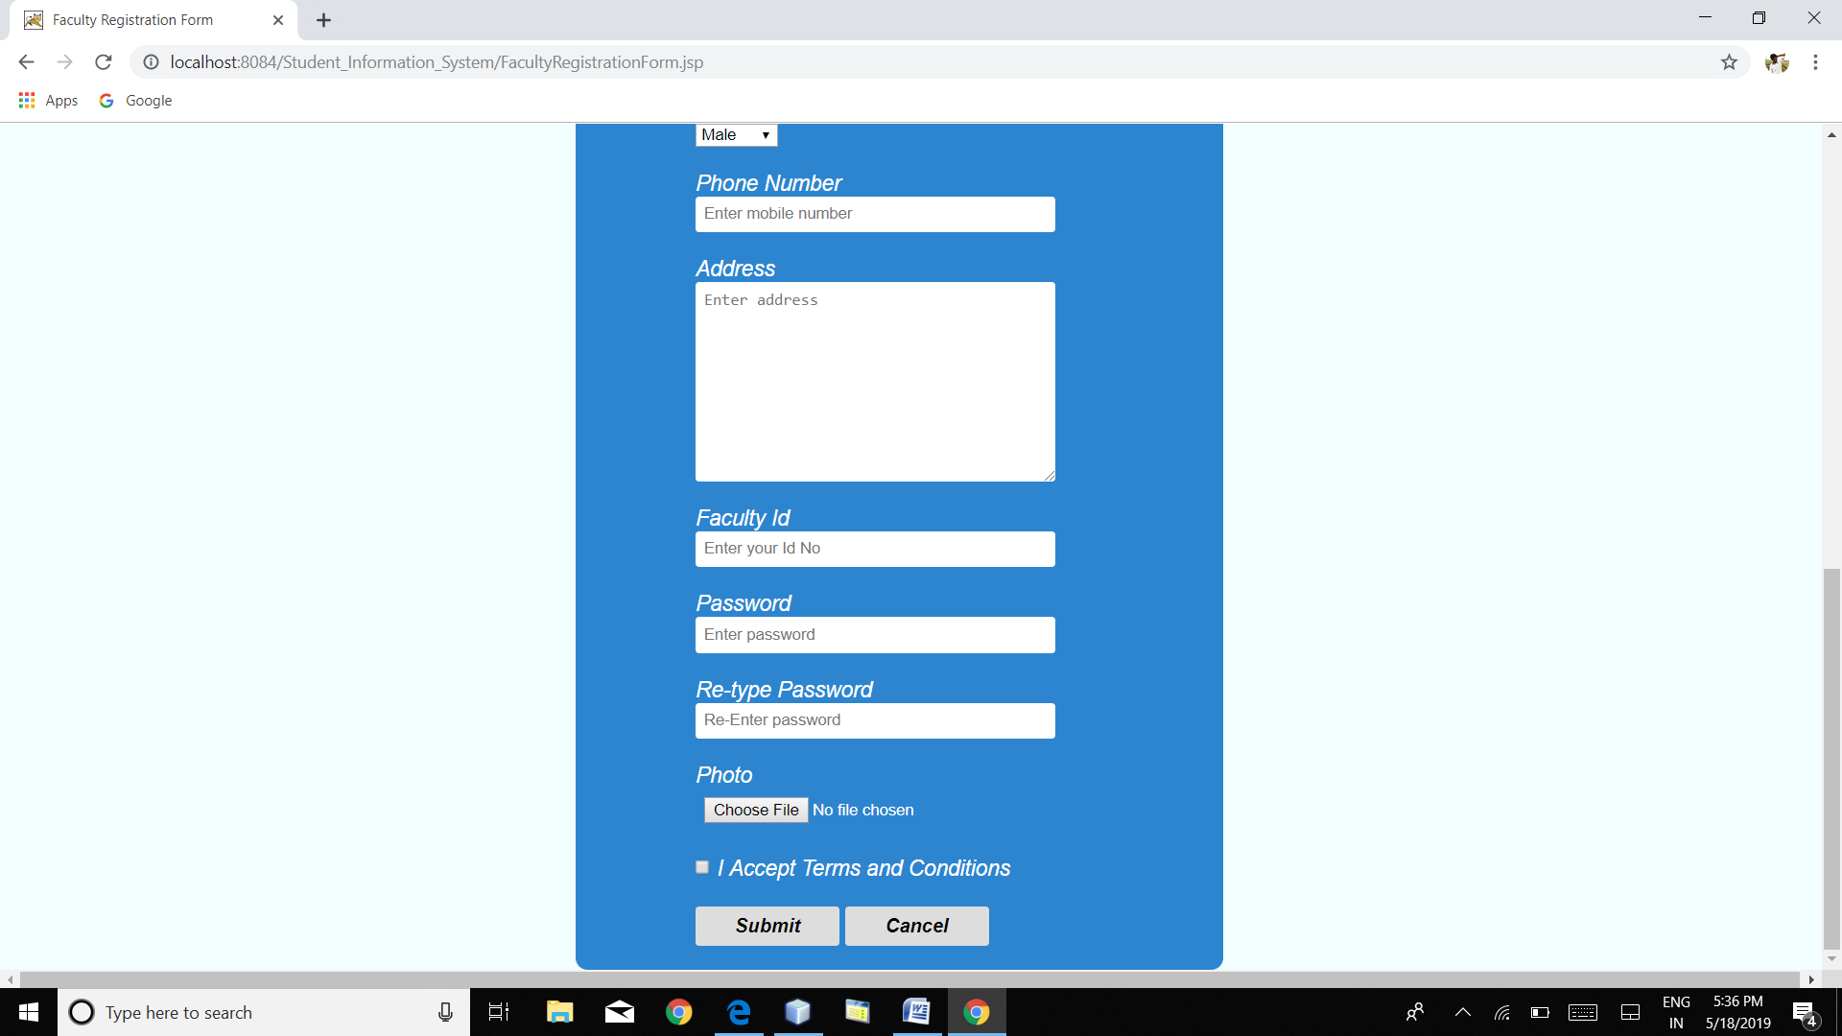

**STUDENT LOGIN**

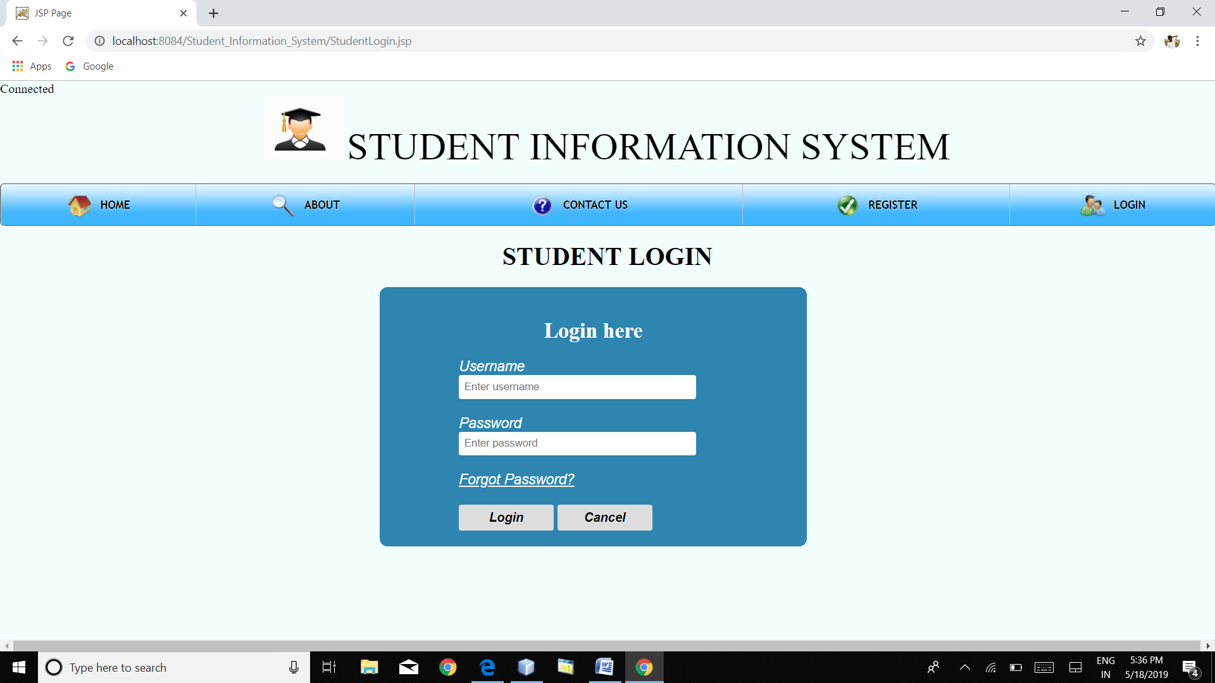

**FACULTY LOGIN**

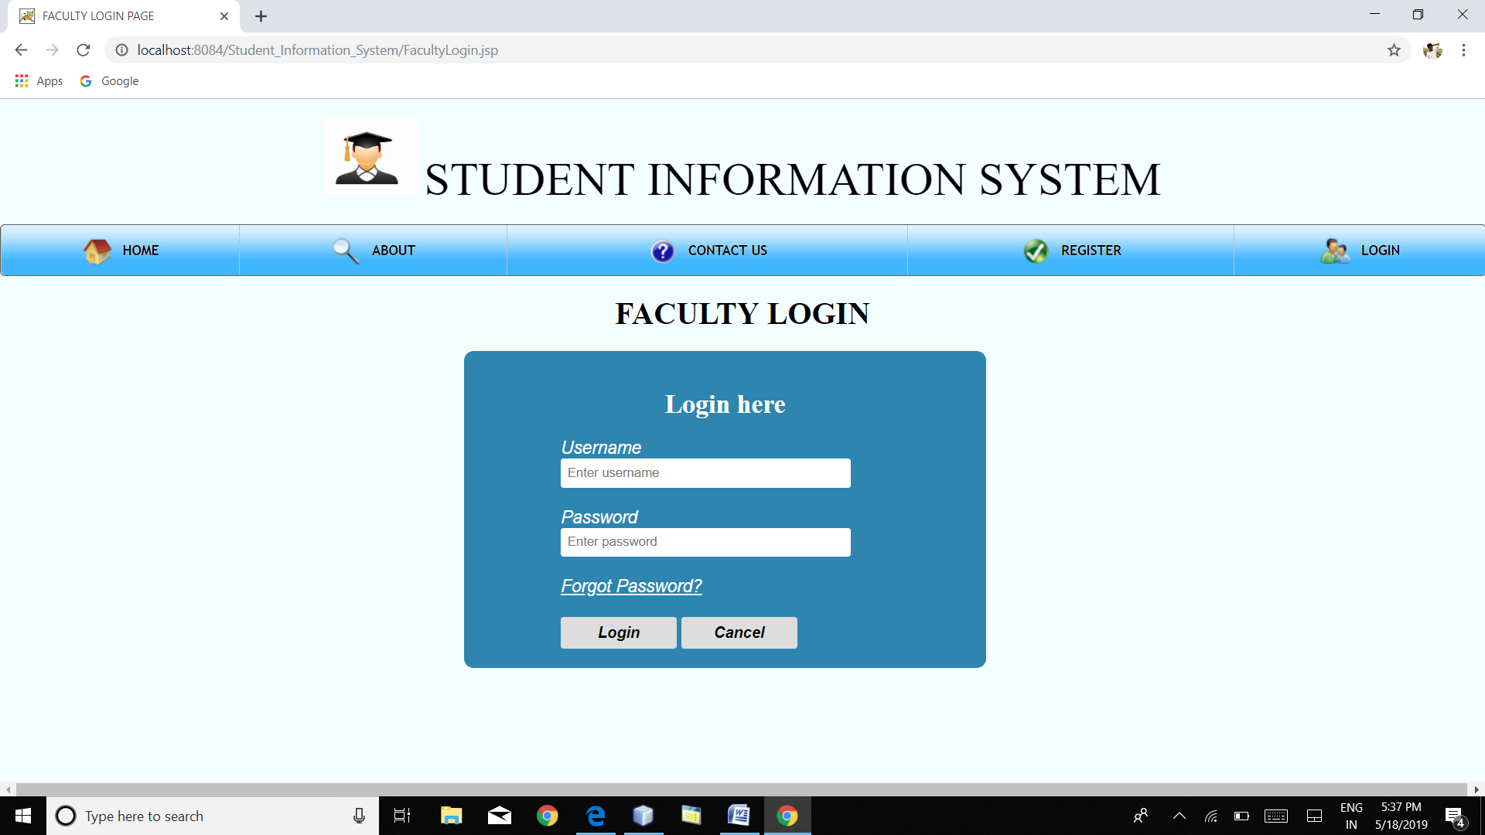

**ADMIN LOGIN**

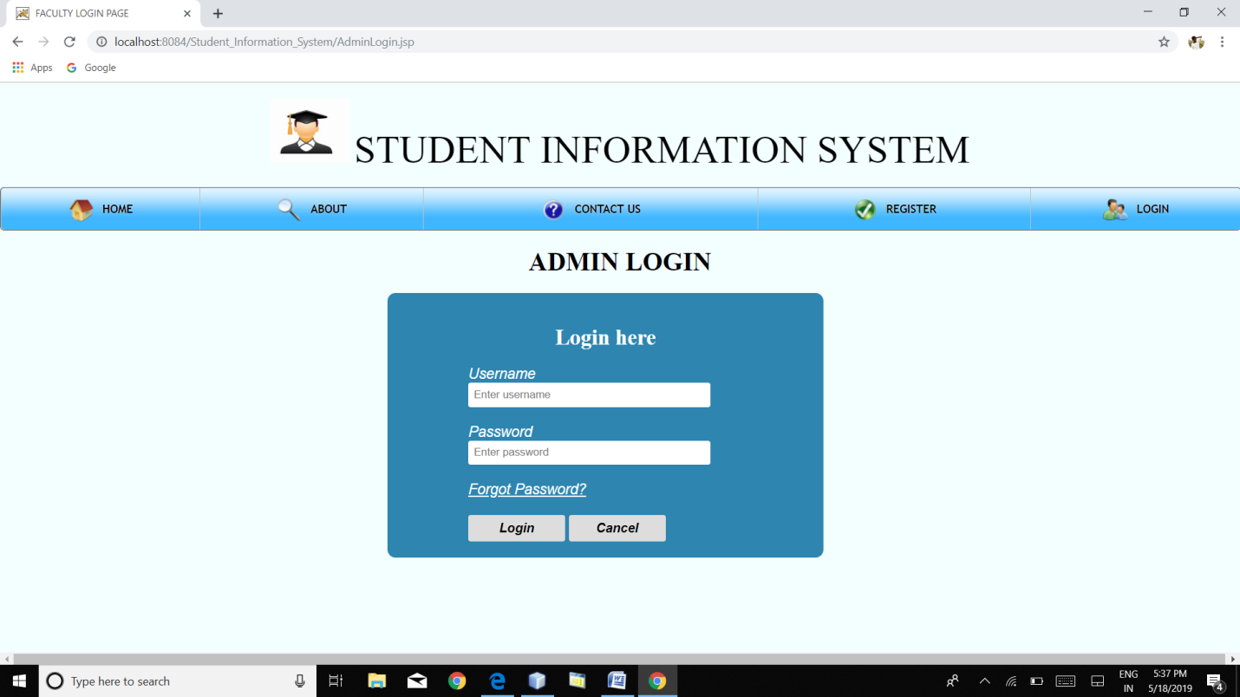

**STUDENT PROFILE**

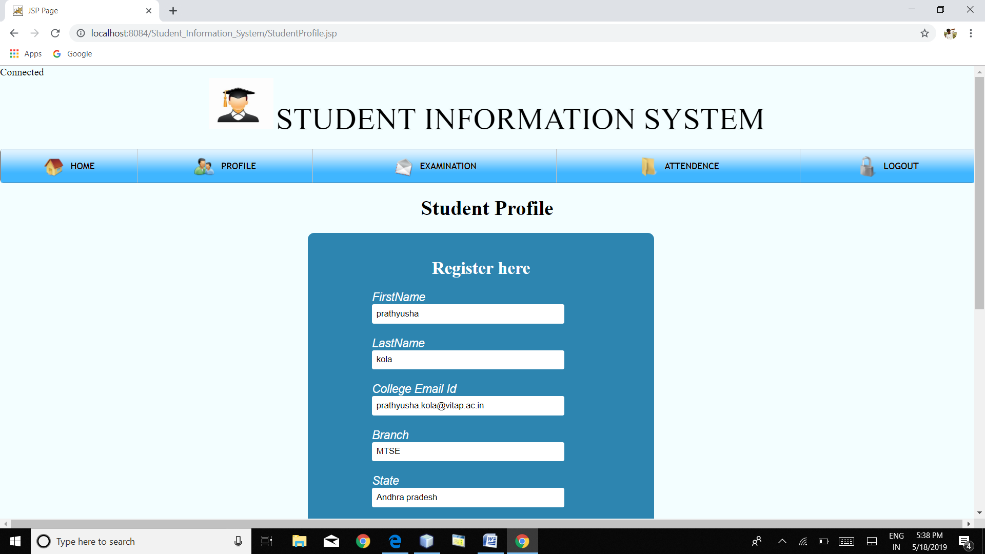

**VIEW CAT MARKS**

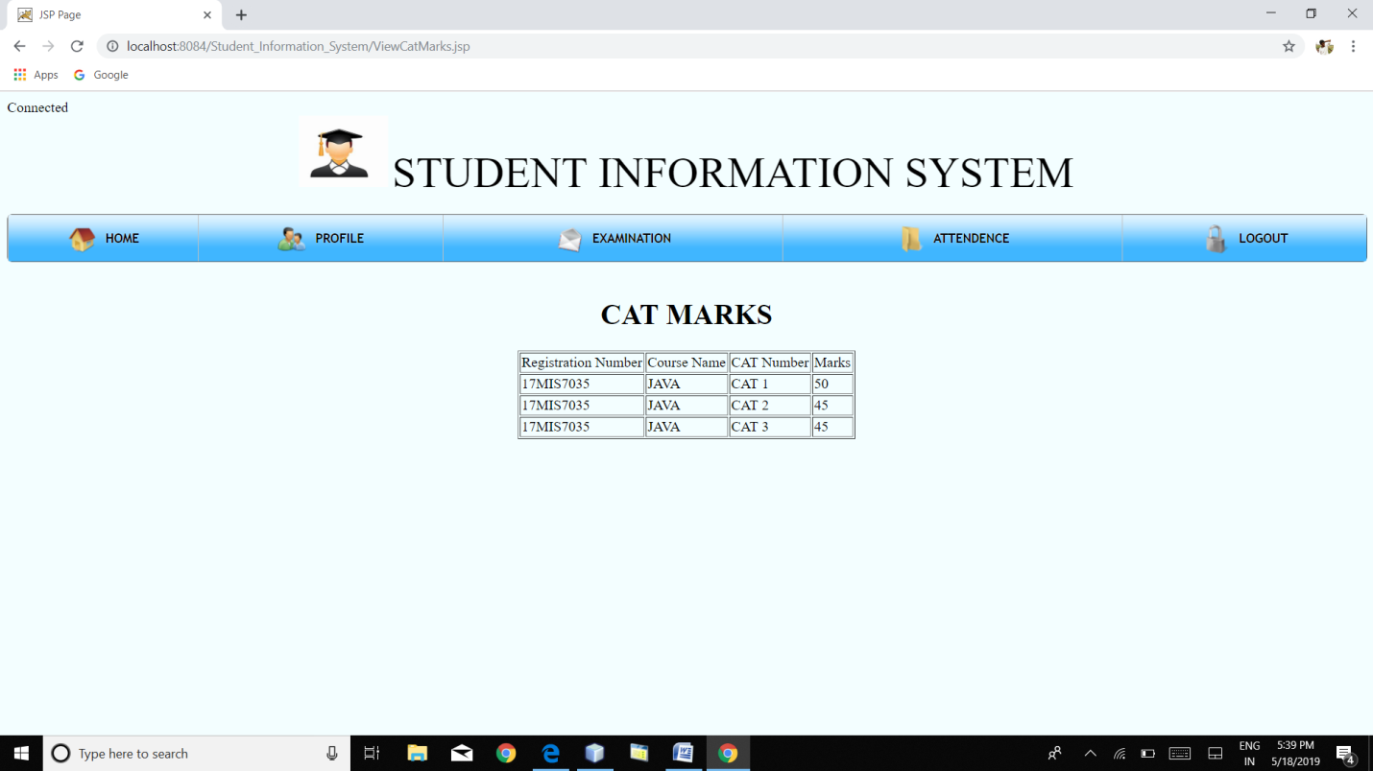

**VIEW ASSIGNMENT MARKS**

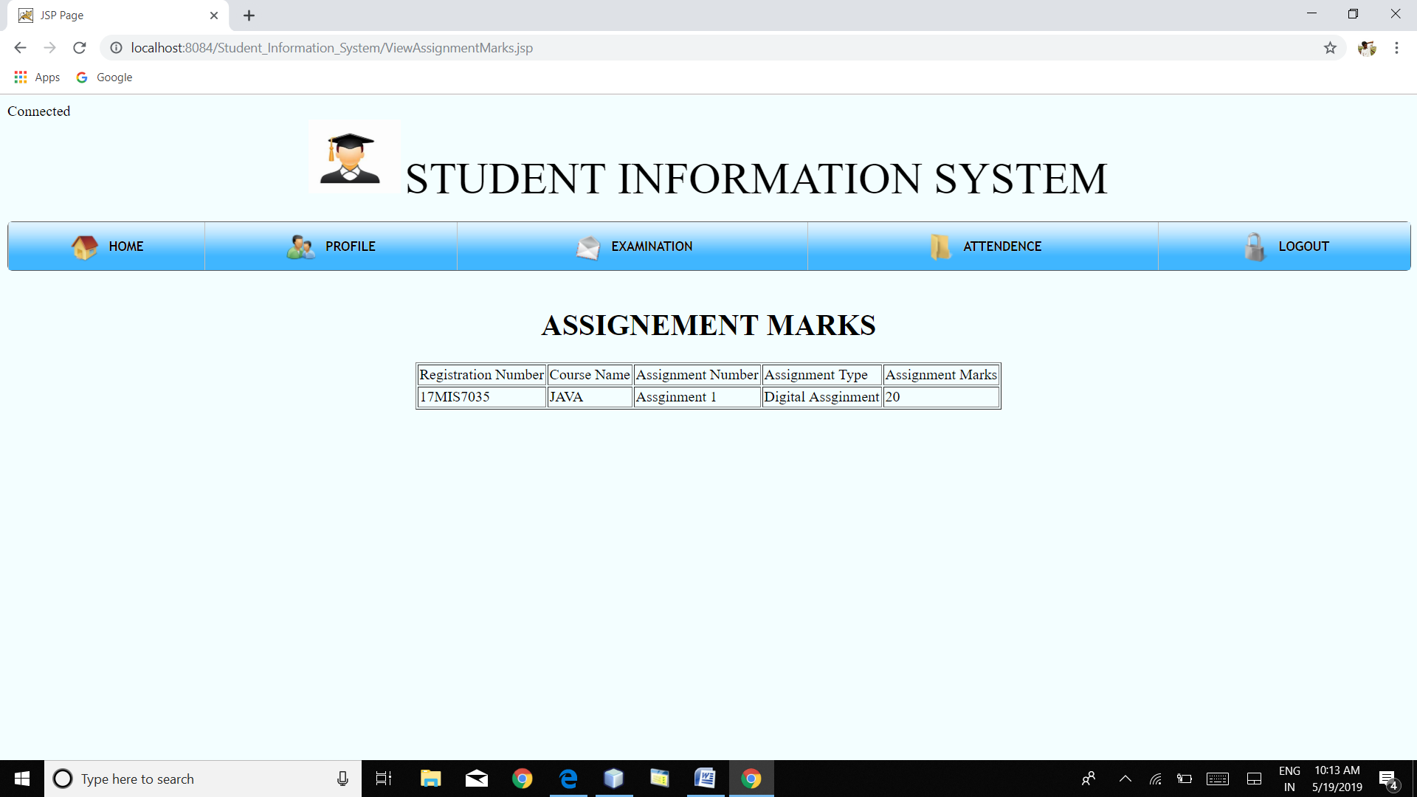

**VIEW INTERNAL MARKS**

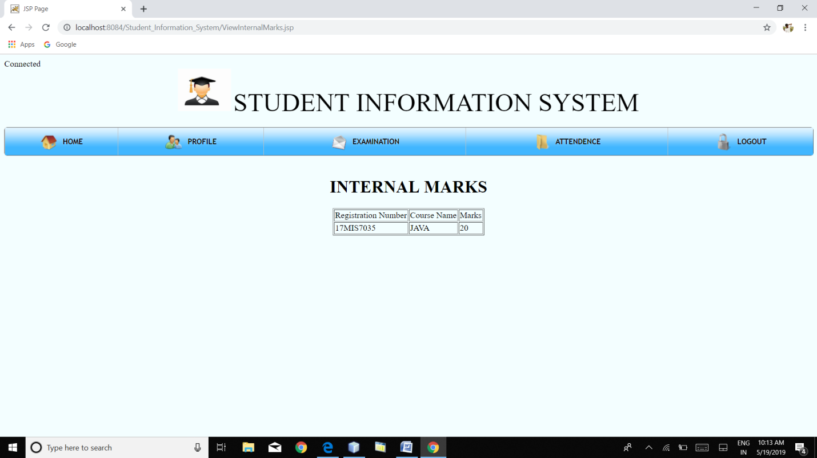

**VIEW ASSIGNMENTS**

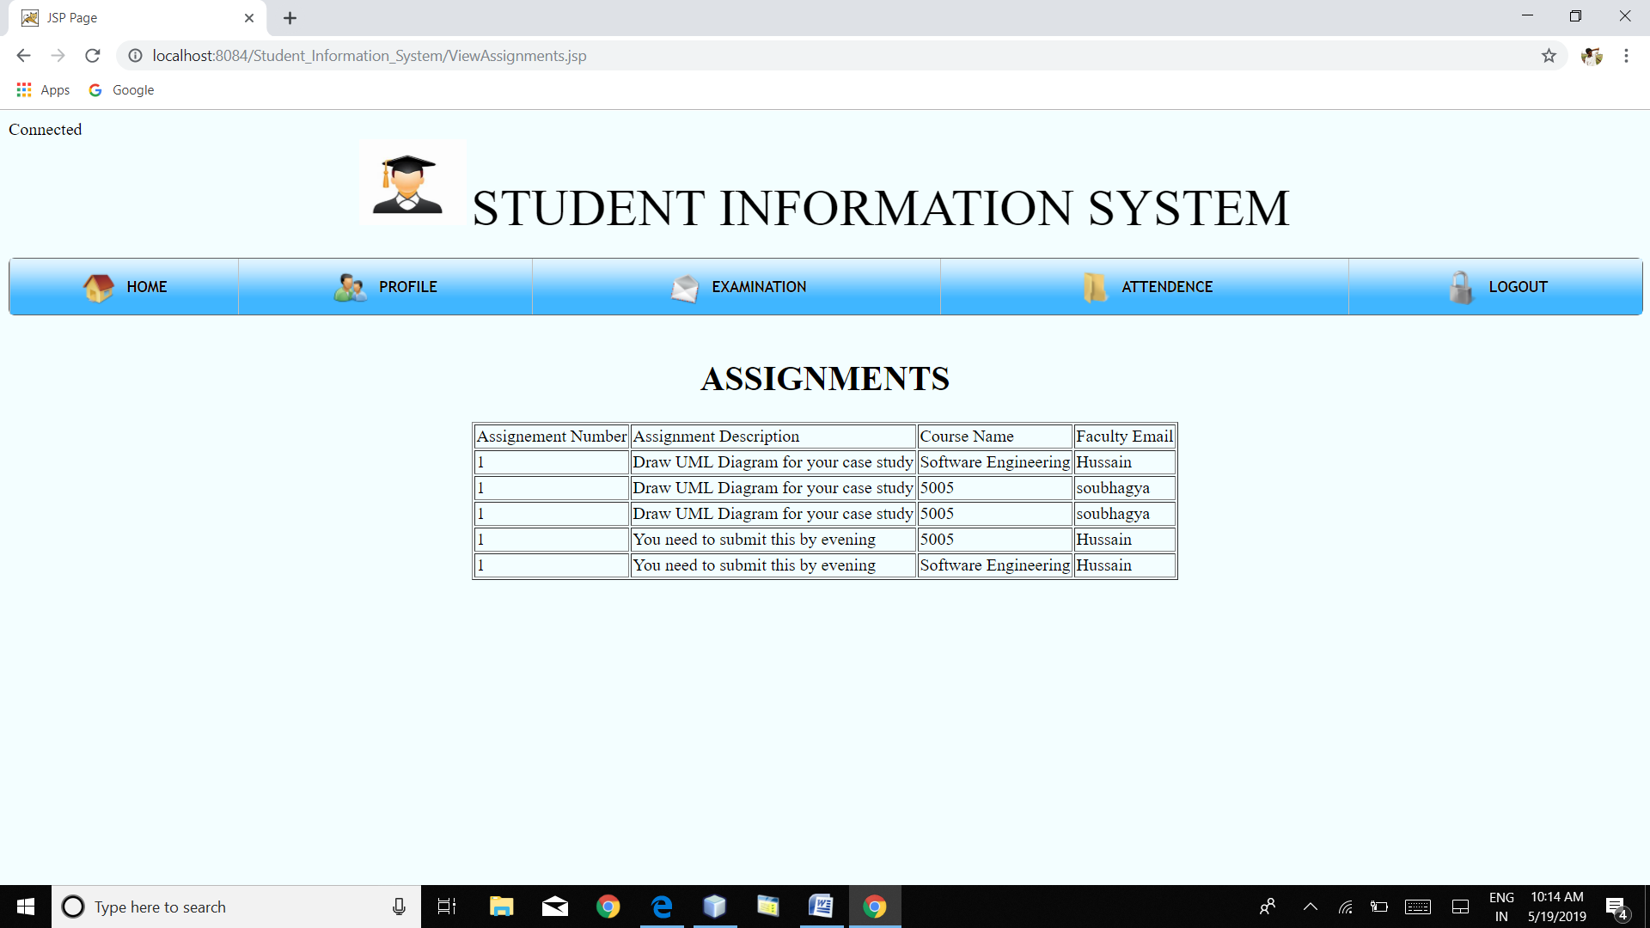

**VIEW GRADES**

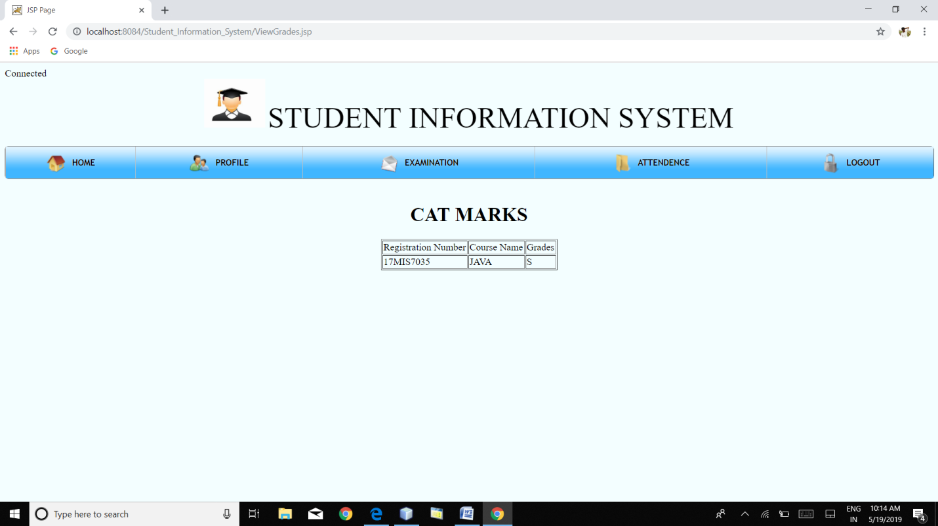

**VIEW ATTENDANCE**

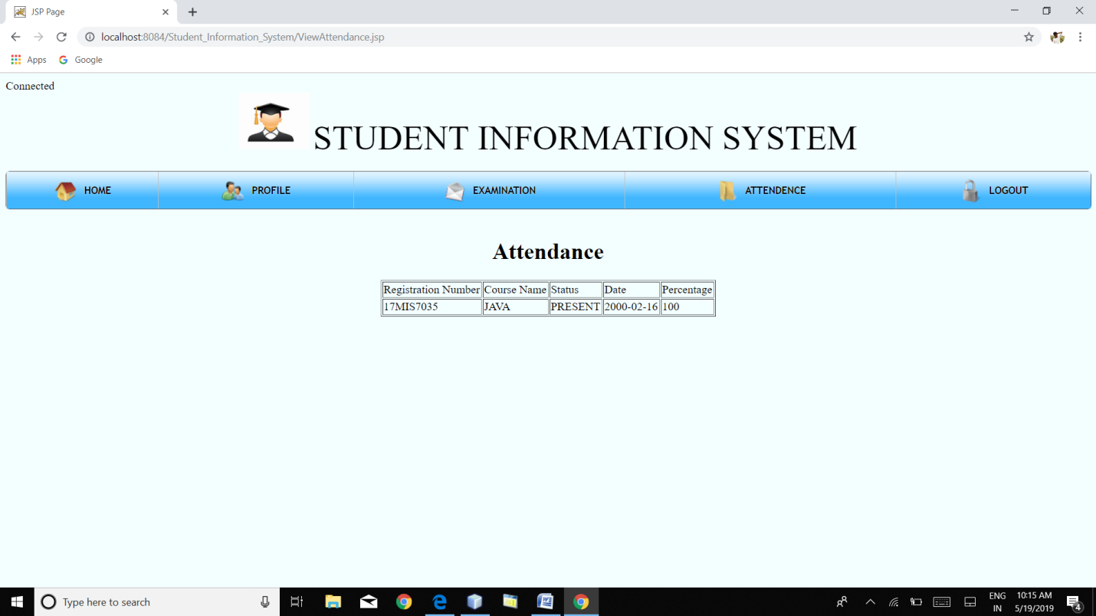

**FACULTY PROFILE**

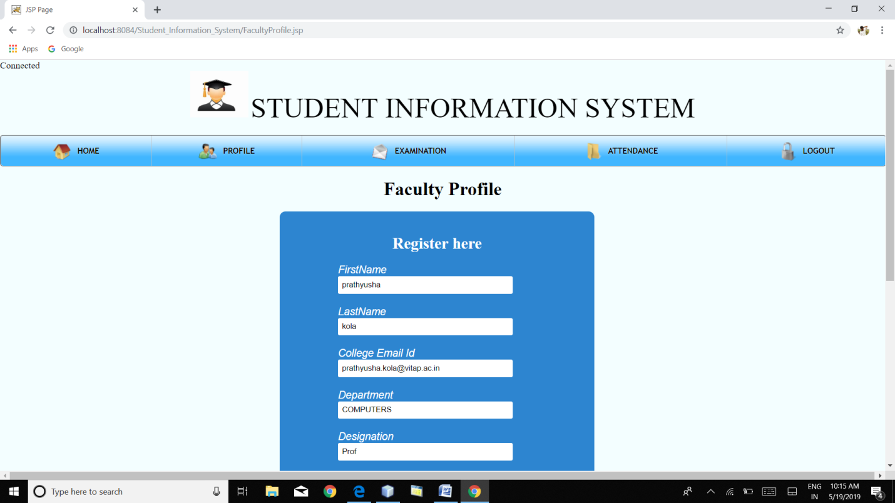

**ASSIGN CAT MARKS**

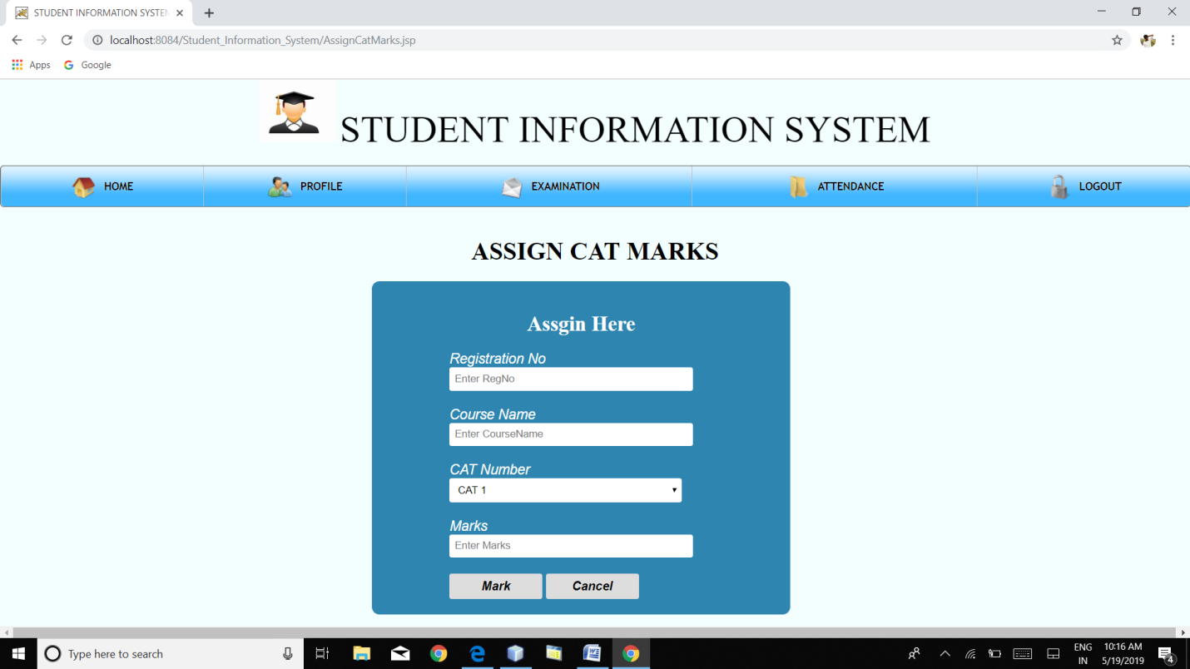

**ASSIGN ASSIGNMENT MARKS**

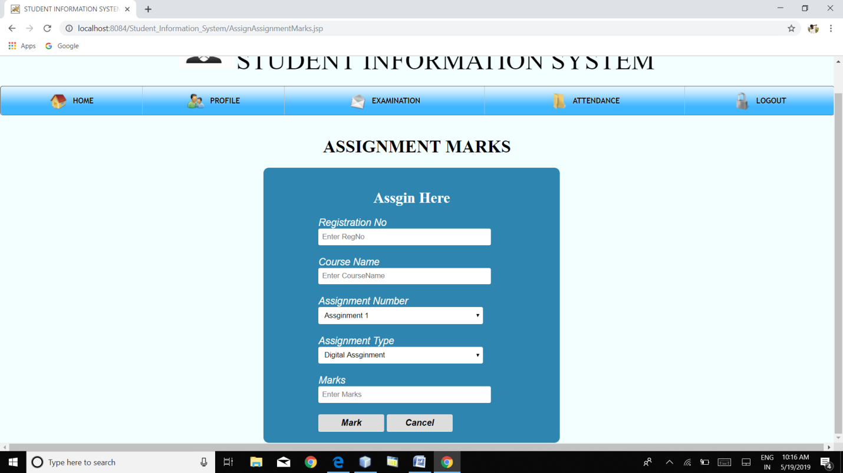

**ASSIGN INTERNAL MARKS**

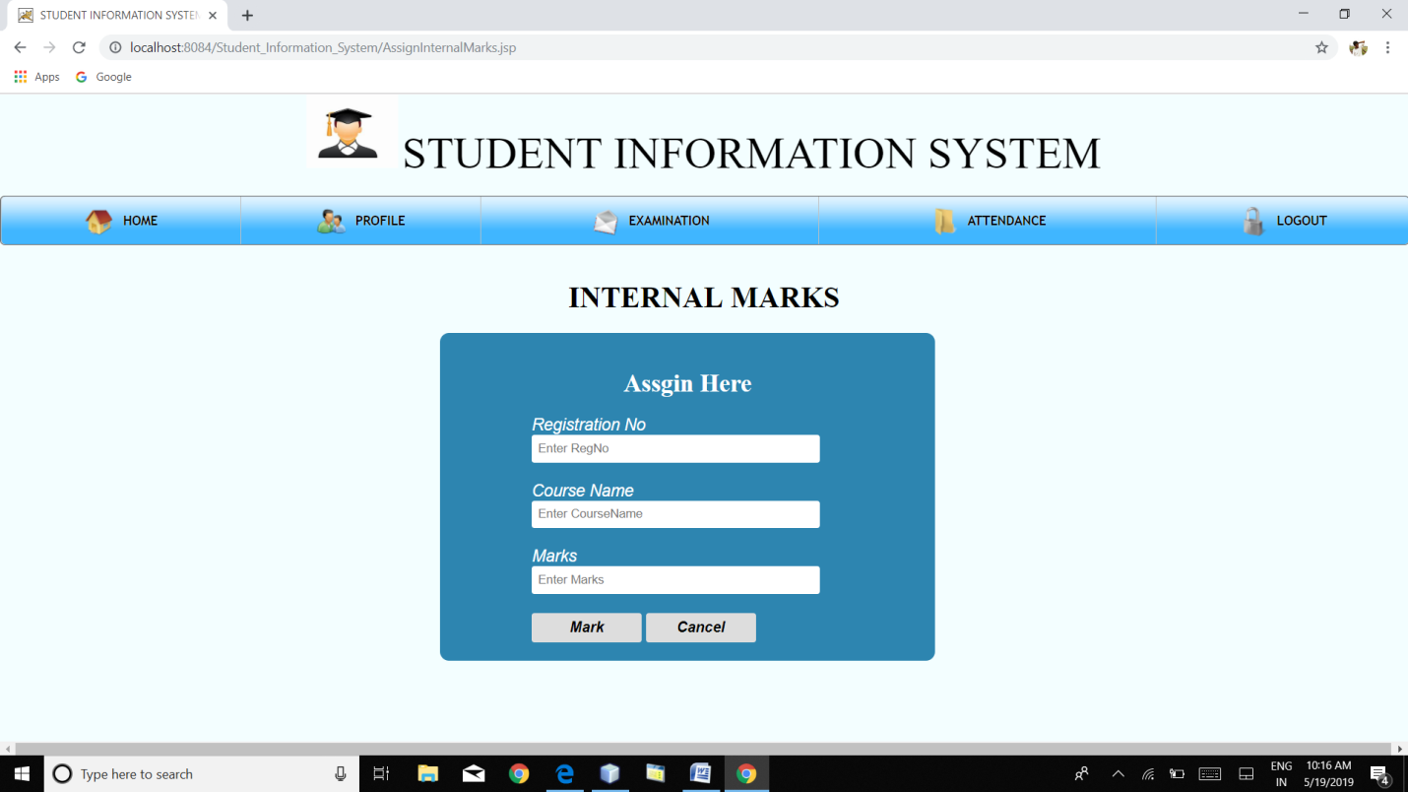

**GIVE ASSIGNMENT**

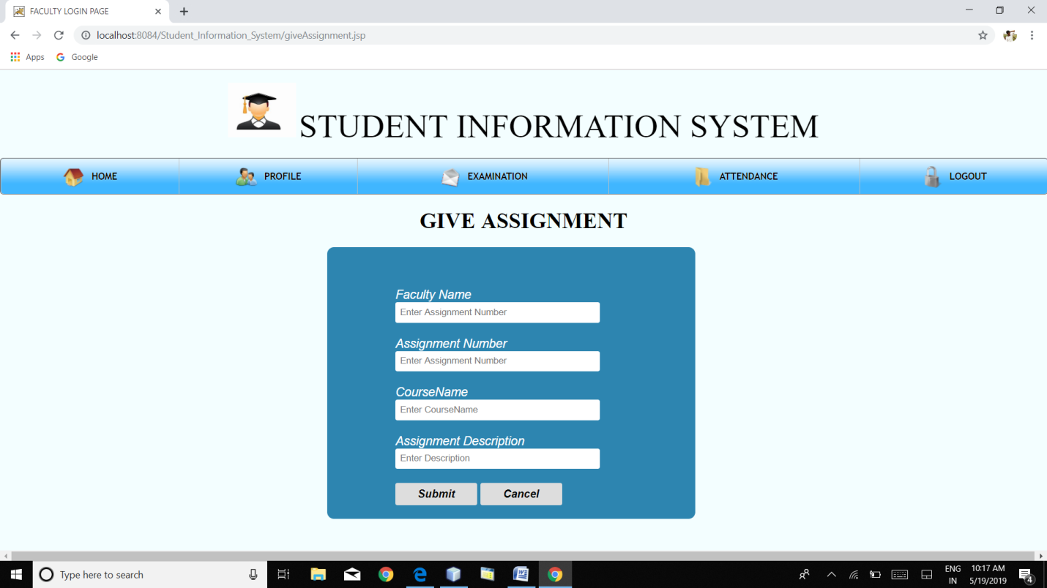

**GIVE GRADES**

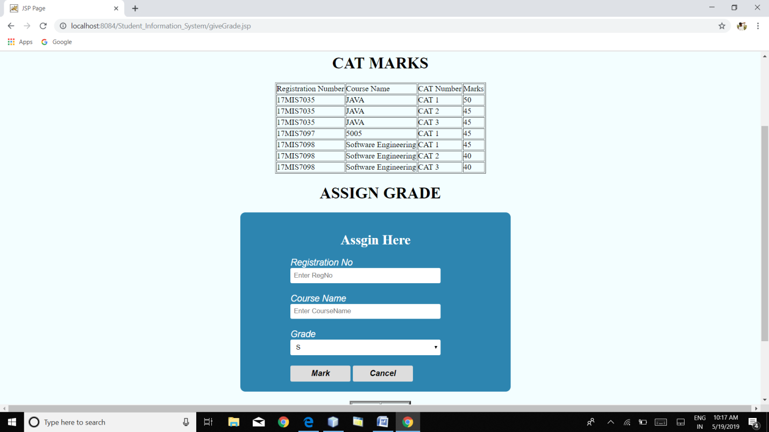

**MARK ATTENDANCE**

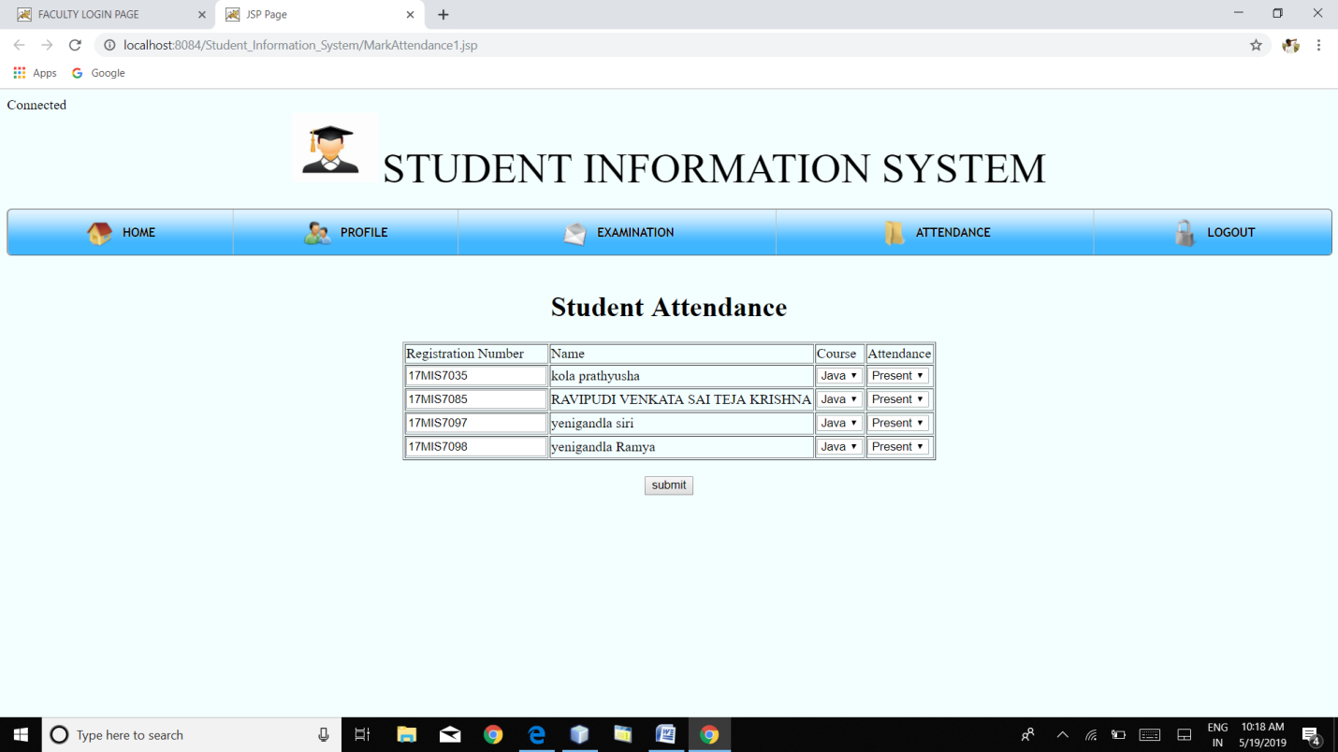

**ADMIN VIEW STUDENT PROFILES AND CAN UPDATE/DELETE**

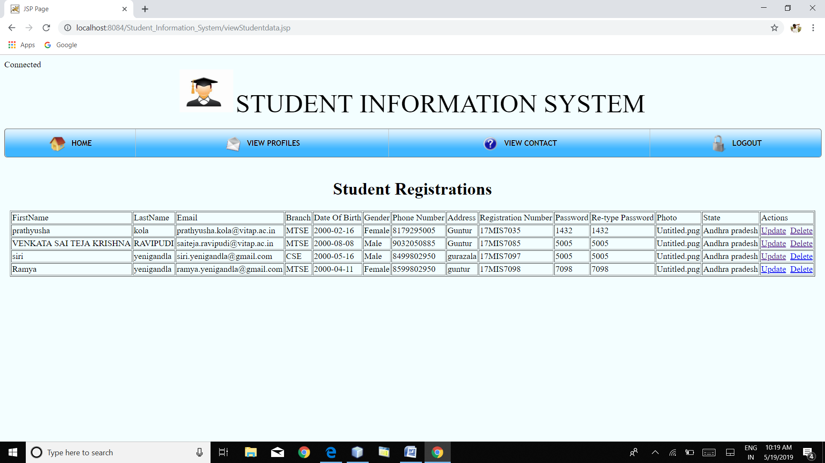

**ADMIN VIEW FACULTY PROFILES AND CAN UPDATE/DELETE**

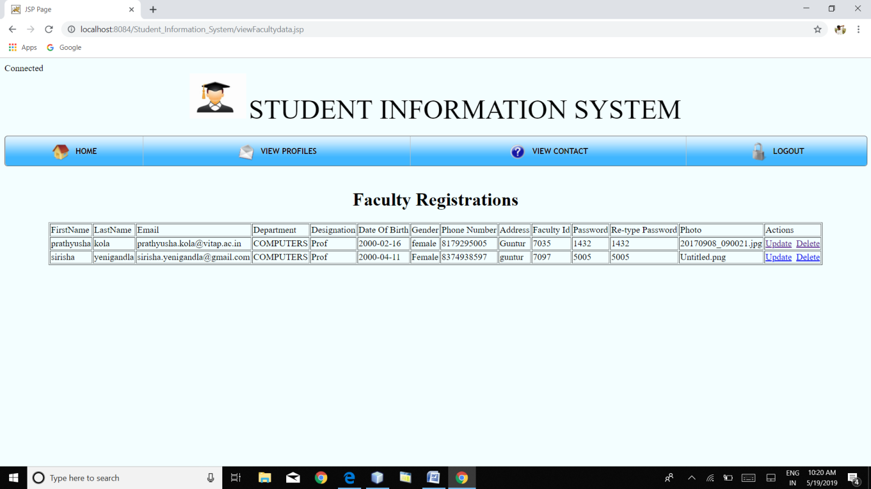

**VIEW DESCRIPTION OF OTHERS GIVEN IN CONTACT US PAGE**

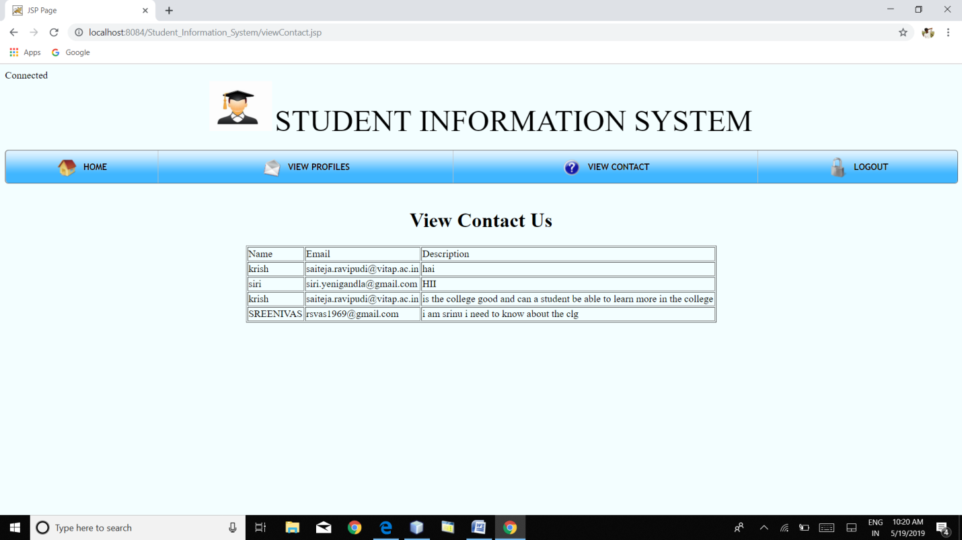

**10. DATABASE DESIGN**

**STUDENT REGISTRATIONS TABLE**

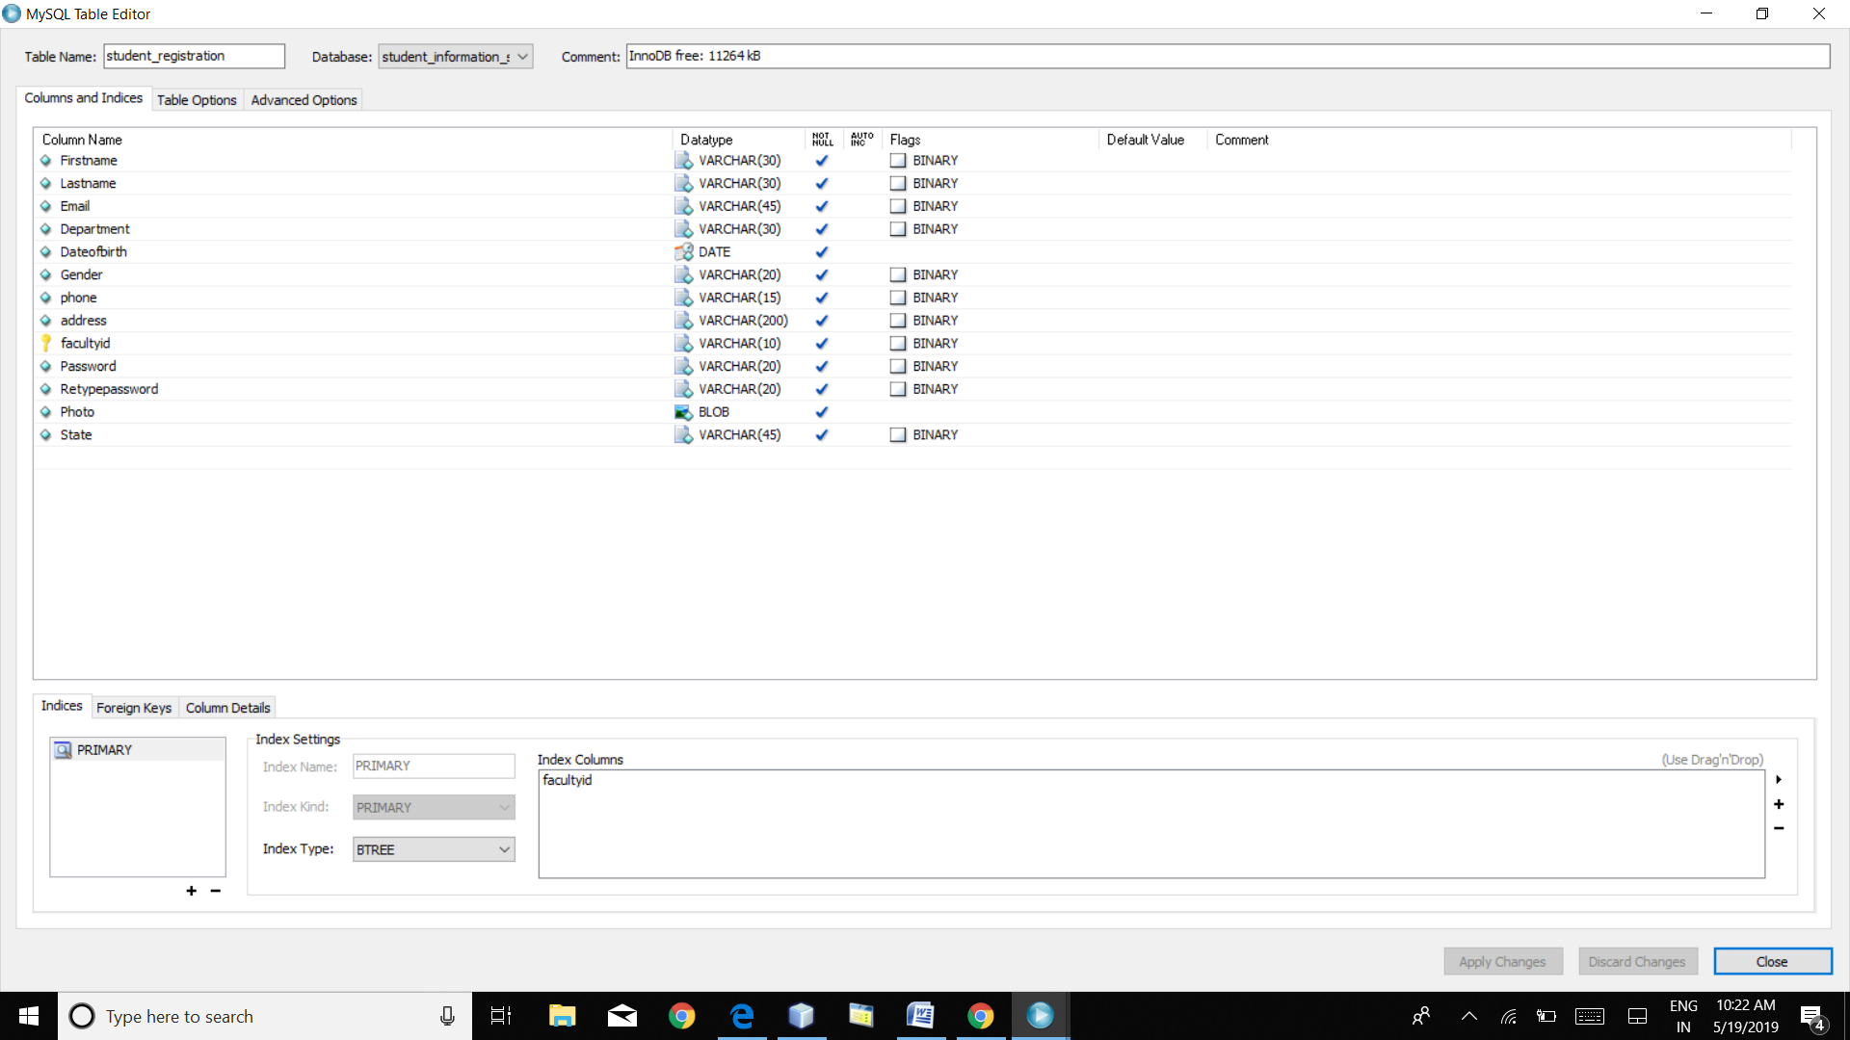

**FACULTY REGISTRATION TABLE**

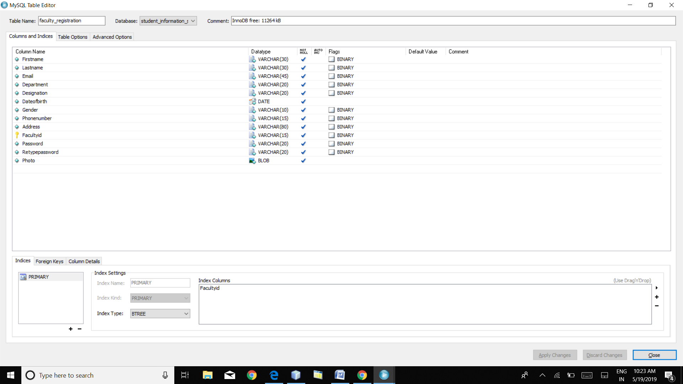

**ADMIN TABLE**

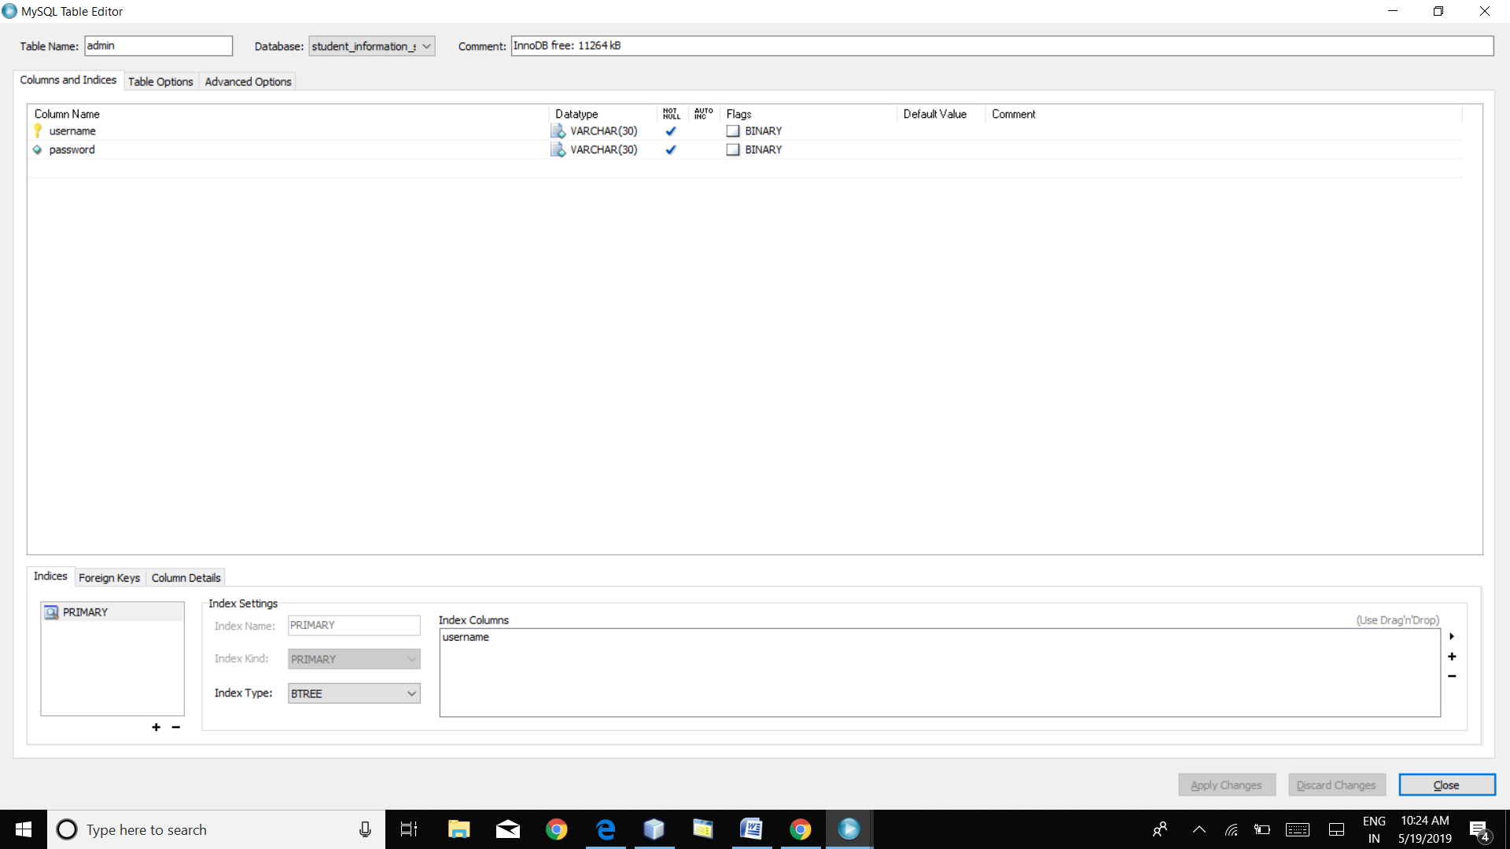

**ASSIGNMENT MARKS**

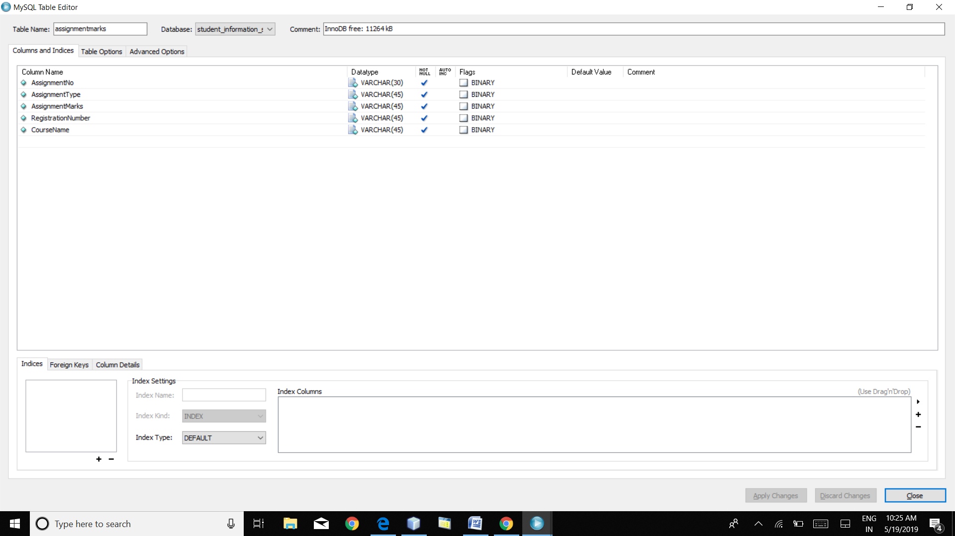

**ASSIGNMENTS**

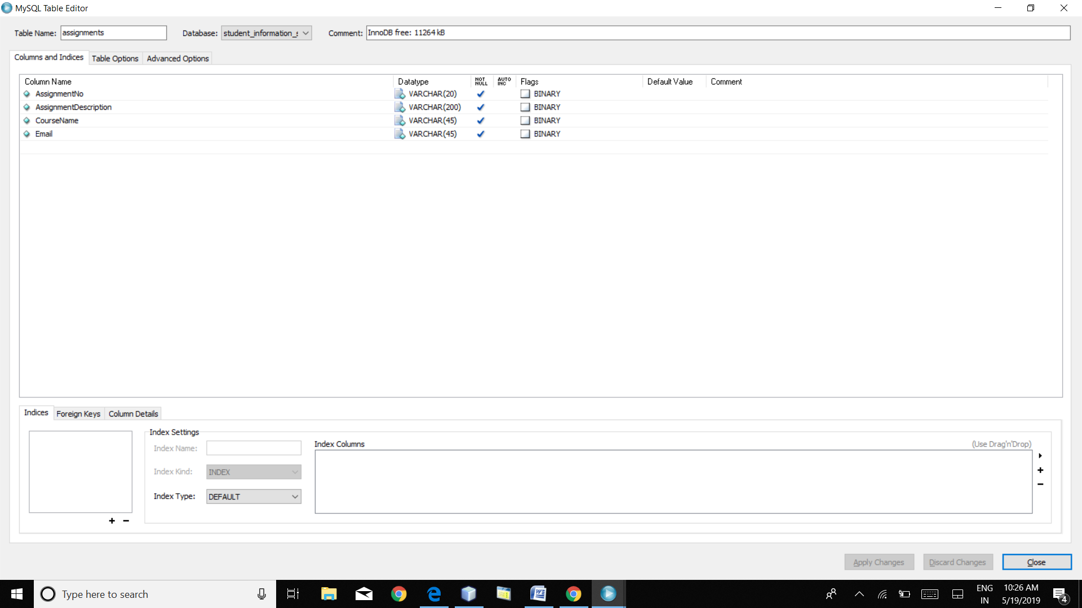

**ATTENDANCE**

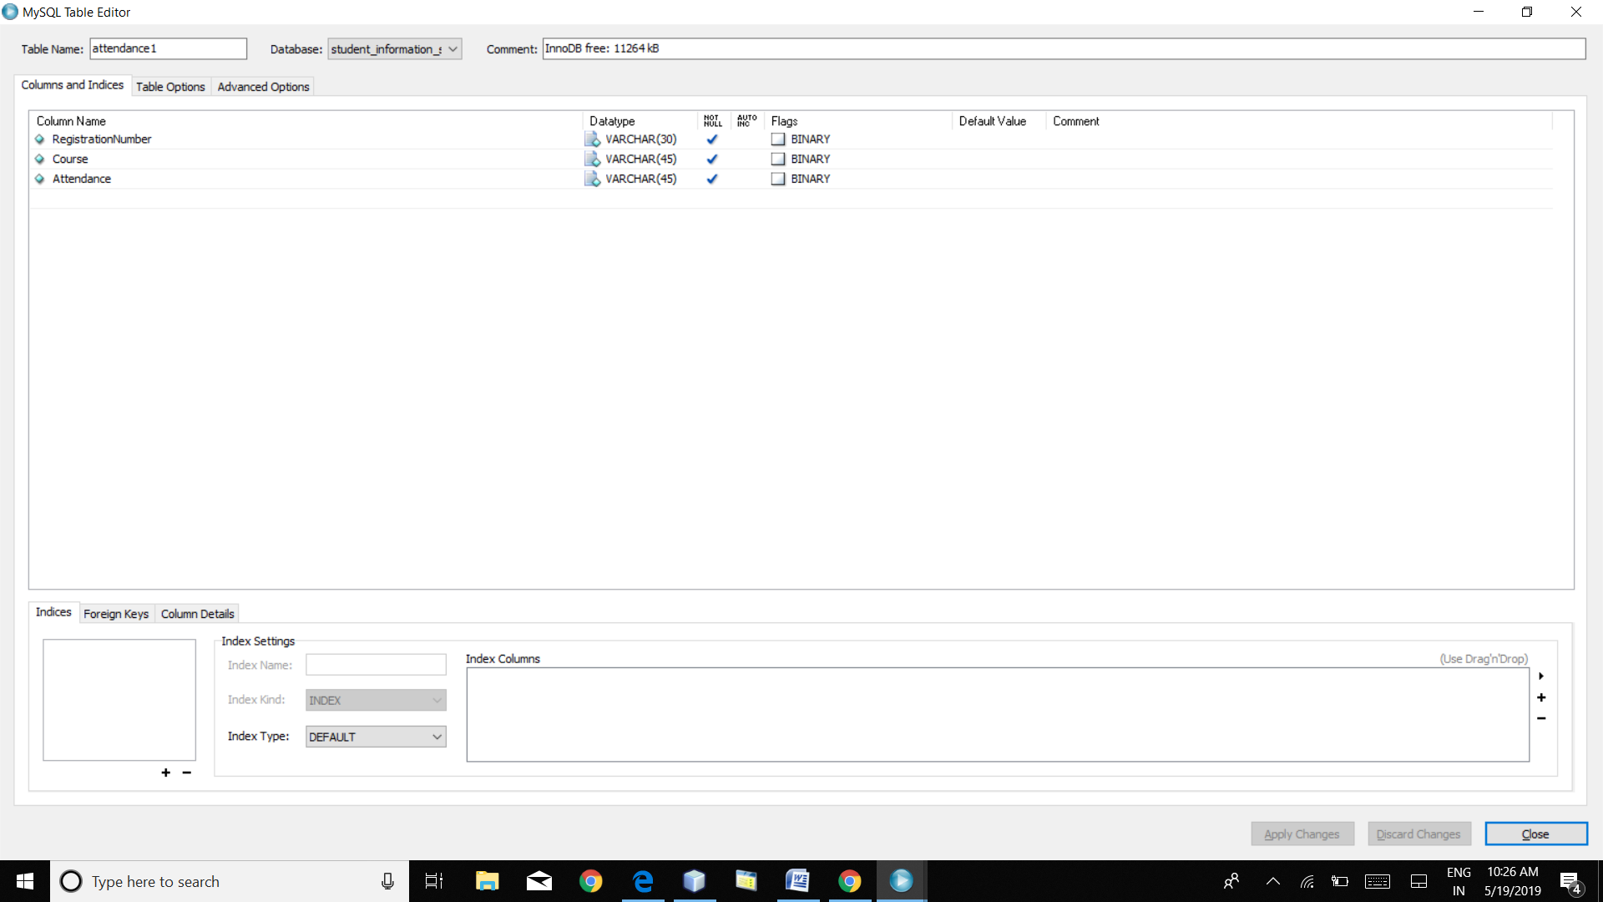

**CAT MARKS**

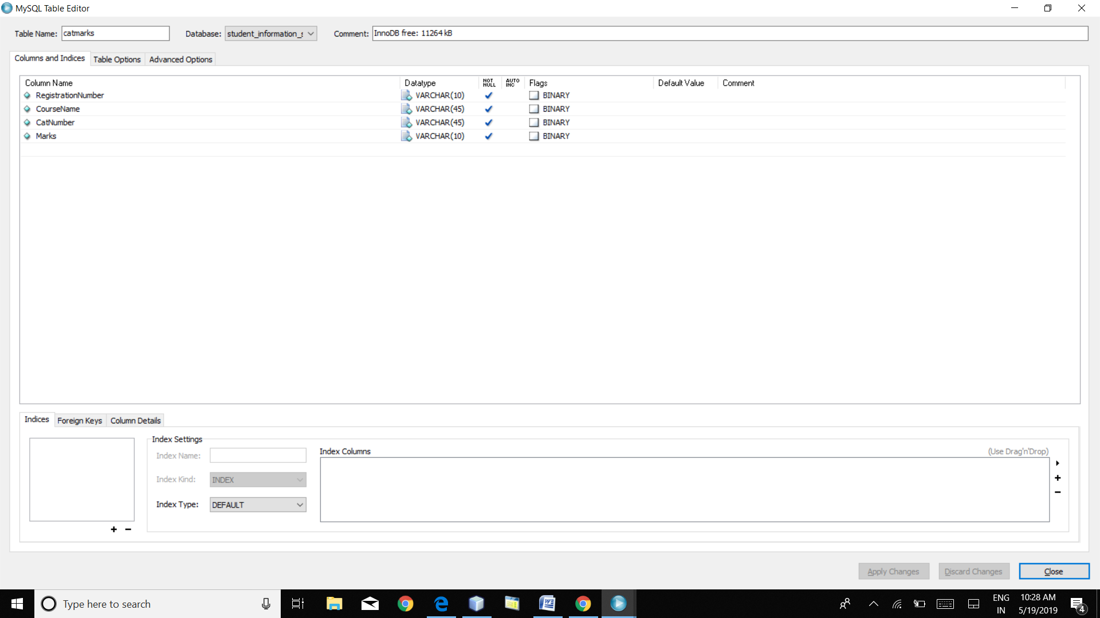

**CONTACT US**

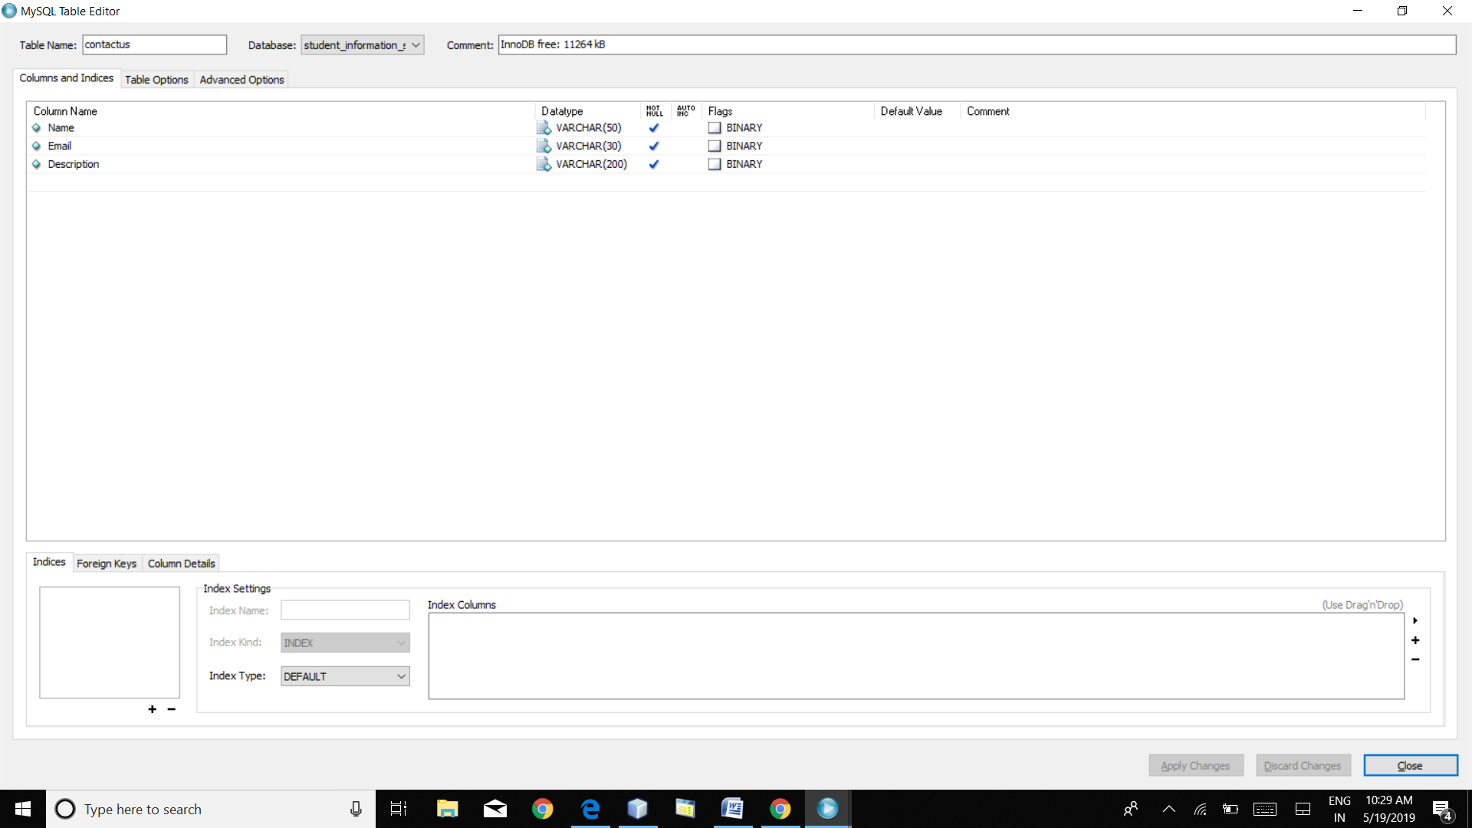

**GRADES**

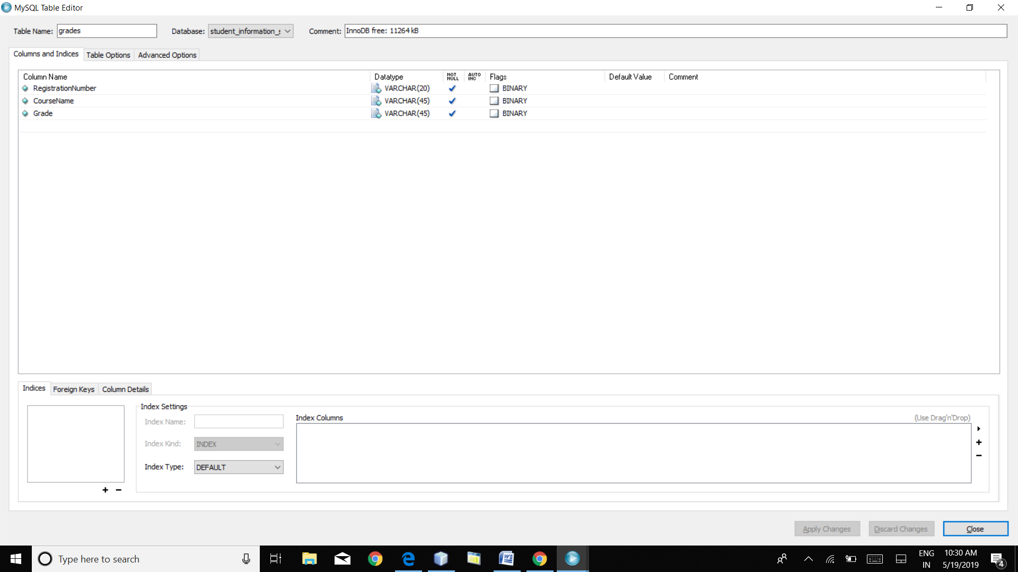

**INTERNAL MARKS**

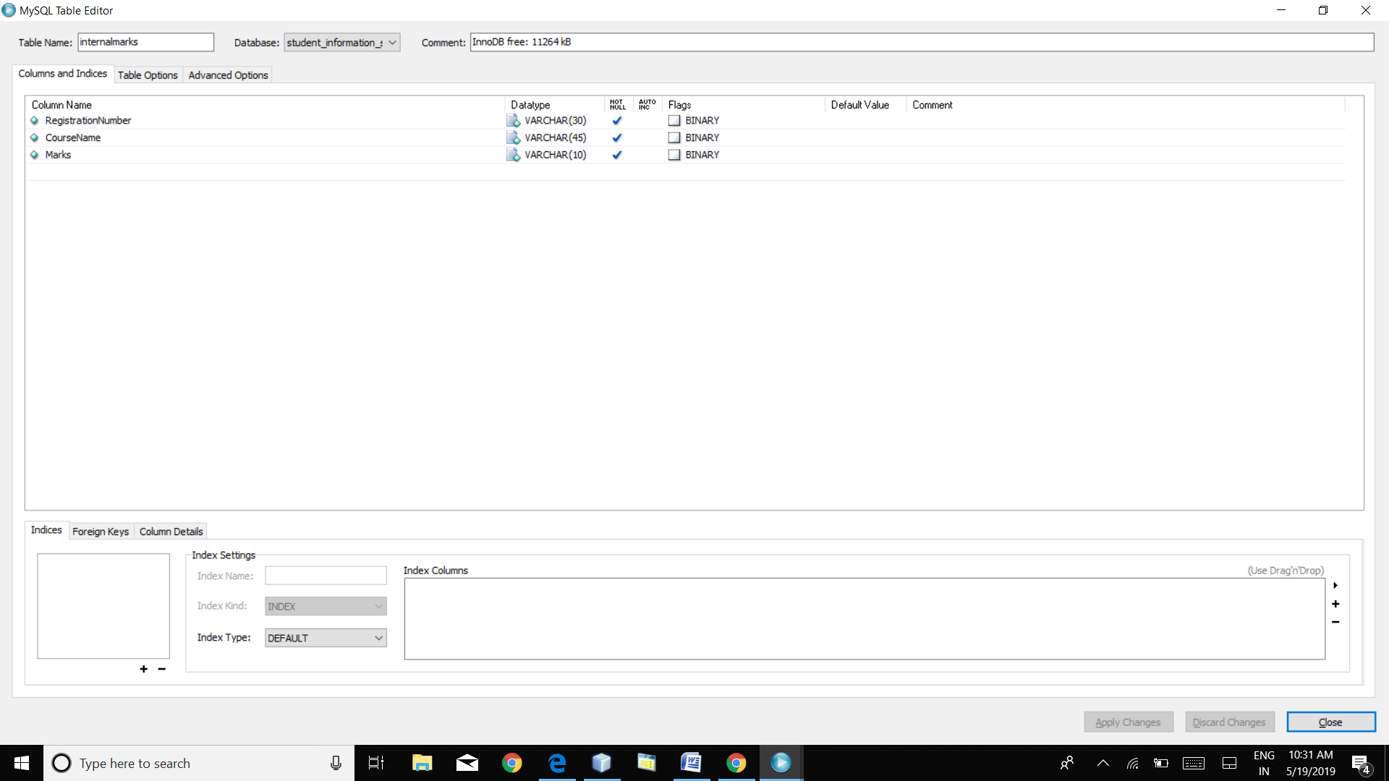

**11. TEST PROFILE, TEST PLAN**

**INTRODUCTION:**

Software testing is a critical element of software quality assurance and represents the ultimate review of specification, design and coding. In fact, testing is the one step in the software engineering process that could be viewed as destructive rather than constructive.

A strategy for software testing integrates software test case design methods into a well-planned series of steps that results in the successful construction of software. Testing is the ser of activities that can be planned in advanced and conducted simultaneously. The underlying motivation of program testing to affirm software quality with methods that can economically and effectively is applied to both strategic to both large and small-scale systems.

The following are the testing objectives:

* Testing is a process executing a program with the intent of finding an error.
* A good test has a high probability of finding an as yet undiscovered error.
* A successful test is one that uncovers an as yet undiscovered error.

**DESIGN OF TEST CASES AND SCENARIOS:**

The objective is to learn tests that systematically uncover different classes of errors and do so with a minimum amount of time and effort. Testing cannot show the absence of defects, it can only show that software defects are present.

**Unit Testing:**

* Interface
* Number of input characters should be equal to number of arguments.
* Parameters and arguments attributes must match.
* Parameters passed should be in correct order.
* Global variable definitions consistent across module.
* If module does I/O.
* File attribute should be correct.
* Open/Close statements must be correct.
* Format specifications should match I/O statements.
* Buffer size should match record size.
* Files should be opened before use.
* End of file condition should be handled.
* I/O errors should be handled.
* Any textual errors in output information must be checked.
* Local Data Structures (common source of errors).
* Improper or inconsistent typing.
* Erroneous initializing or default values.
* Incorrect variable names.
* Inconsistent data types.
* Overflow, underflow, address exception.
* Boundary conditions and independent paths.
* Error handling.
* Error description unintelligible.
* Error noted does not correspond to error encountered.
* Error condition handled by system run-time before error handler gets control.
* Exception condition processing incorrect.

**Integration Testing:**

Module integrated by moving down the program design hierarchy. Can use depth firs**t** or breadth first top down integration verifies major control and decision points early in design process. Top-level structure tested most. Depth first implementation allows a complete function to be implemented, tested and demonstrated and does depth first implementation of critical function early. Top down integration forced (to some extend) by some development tools in program with graphical user interfaces. Begin construction and testing with atomic modules (lowest level modules).

Bottom up integration testing as its name implies being construction and testing with atomic modules. Because modules are integrated from the bottom up, processing required for module subordinate to a given level is always available and the need for stubs is eliminated.

**Top-Down Integration:**

Top-Down Integration testing is an incremental approach to construction of program structure. Modules are integrated by moving download through the computer hierarchy, beginning with the main control module.

The Top-Down integration process is performed in the following five steps:

The main control module is used as a test driver and subs are substituted for all the components directly subordinate to the main control module.

Depending on the integration approach selected, subordinate stubs are replaced one at a time with actual components.

Tests are conducted as each component is integrated.

On completion of each of test, another stub is replaced with the real components.

Regression testing may be conducted to ensure that new errors have not been introduced.

**Bottom-Up Integration:**

Bottom-Up Integration testing as its name implies, being construction as testing with atomic modules because components are integrated from the bottom up, processing required for components subordinate to a given level is always available and for stuns is eliminated.

The Bottom-Up Integration is performed in the following four steps:

Low-Level components are combined into clusters that perform a specific software stub function.

Driver is written to coordinate test case input and output.

The cluster is tested.

**12.CONCLUSION**

The package was designed in such a way that future modifications can be done easily. The following conclusions can be deducted from the development of the project.

* Automation of the entire system improves the efficiency.
* It provides a friendly graphical user interface which proves to be better when compared to the existing system.
* It gives appropriate access to the authorized users depending on their permissions.
* It effectively overcomes the delay in communications.
* Updating of information becomes so easier.
* System security, data security and reliability are the striking features.
* The system has adequate scope for modifications in future if it is necessary.

This application avoids the manual work and the problems concern with it. It is an easy and fast way to access the updates information.